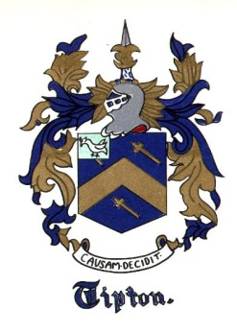
The Tipton Family Association
of America Newsletter

The Tipton Family Association of America
7132 Emily Drive
Fort Myers, FL 33908

Winter 2023

PRESIDENT COMMENTS

Hello Family. I hope your Christmas was full of blessings and Family and your New Year Happy and Healthy.

Most of you all know that I took a little break from working on TFAA projects for a couple of months and now it's time to get back to work. Thankfully TFAA has been growing by leaps and bounds and is quickly becoming a FULL time volunteer job for your board members and with that being said, I will be reaching out for your help with projects that were put on the back burner over the past year. Thank you in advance for your help.

Welcome Gary Scott Tipton to the TFAA board! Scott has volunteered to serve as your new secretary. Gary tells us that he is a direct descendant from the Cades Cove family lines and prior to that, North Carolina, Boston and Europe. He was born in Ohio and spent every summer in and around East Tennessee (Maryville, Townsend, Knoxville) with his grandparents. He moved to Florida a little over 20 years ago but still thinks of Tennessee as "home away from home." His great grandfather was born in Cades Cove. Gary is an avid genealogy hobbyist, paints, enjoys photography, travel, and camping. He has three sons and two step sons and a step daughter. Gary is an IT manager and works for a global fertilizer and agriculture business. Many years ago he was a paramedic firefighter for the City of Dayton, Ohio for almost 10 years. His grandfather, Luther R. Tipton, contributed to the We Tiptons and Our Kin book with many oral stories and information during the research for the book. Gary remembers him being so tickled to get to talk to someone about the family and the history he knew. Luther was also a very popular musician and disc jockey. He was selected as the Mr. Opry DJ in 1964 and is in the Country Music Hall of fame. Gary says his grandfather's brother, James Roy Tipton, served on the board of a Tipton Association during the 1970s and 1980s. He contributed greatly to the maintenance and promotion of the family history over the years.

2023 TFAA reunion/conference will be held in Shenandoah Valley, Virginia.
Due to scheduling conflicts and a possibility of combining it with another event in Woodstock the exact dates in October have not yet been determined. More information and the agenda will be emailed out soon.

Family, as I speak to folks and conduct research, I am discovering that some of our family trees are INCORRECT! Unfortunately what is happening is that folks (including myself) find a tree and copy it to ours as we believe it is absolutely correct but, unfortunately, it isn't. Or someone in the family has passed along family lore for years and over the years the story becomes a bit watered down or changed in some form or fashion. I beg you to please include documents and facts to your family tree.

2023 is going to be an amazing year!!!

TIPTON TEAMWORK!!!

Kathy Hoffmann, TFAA President
239-994-1246
peachyrose56@gmail.com

TFAA COMMITTEE

President - Kathy Hoffmann
Co-President - Cathy Tipton Lowe
Treasurer - Vacant
Secretary – Gary Scott Tipton
Communications Director - Charles Tipton (aka Junior)
TFAA Tipton Research Director - Charlotte West Dade
Tipton Family DNA project Administrators - Bob Tipton and Bonnie Grant
Editor – David Etter

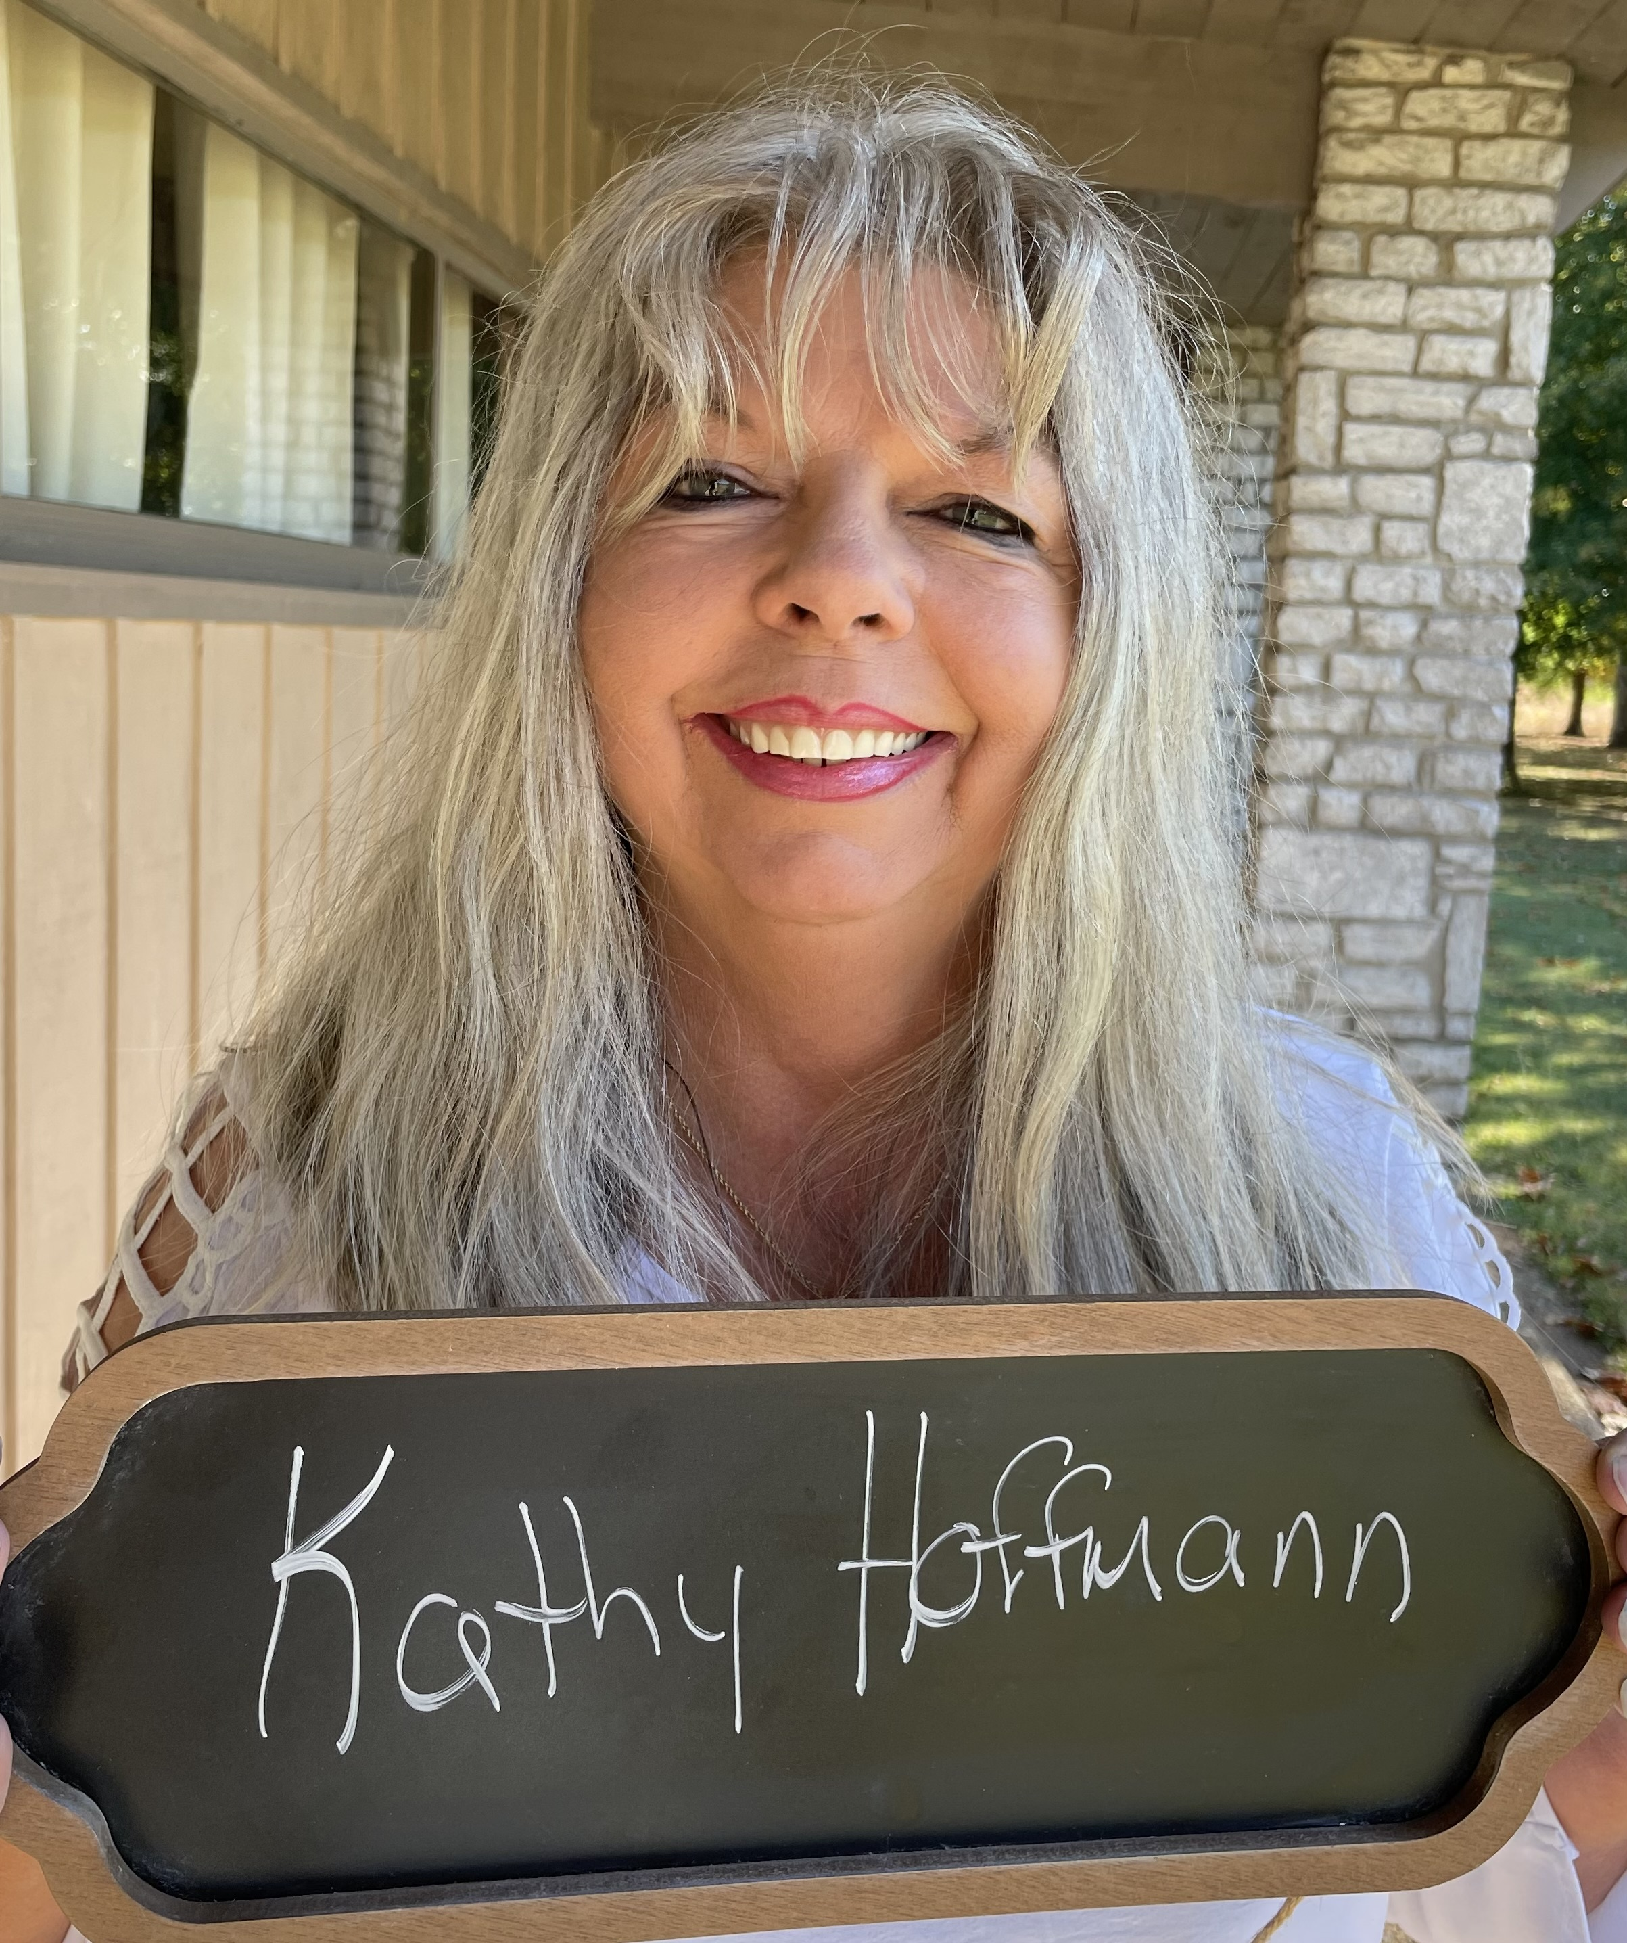Kathy Hoffmann, president
Cathy Tipton Lowe, copresident

Gary Scott Tipton, secretary
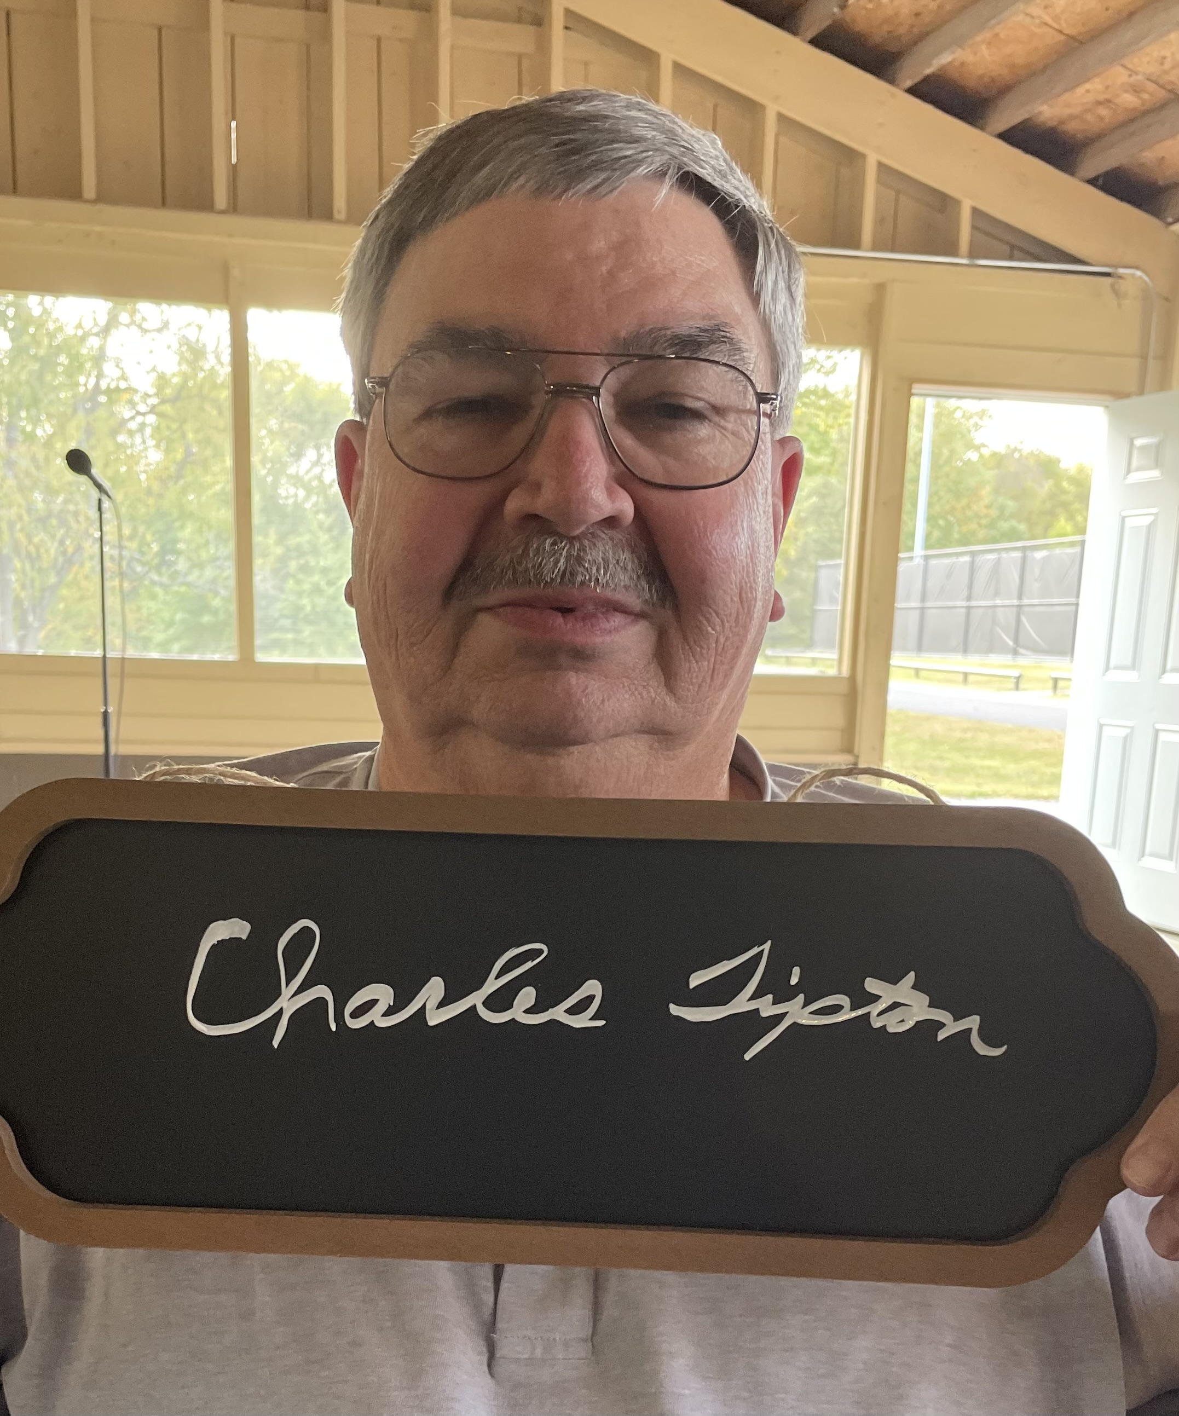Charles Tipton, Communications Director

Charlotte West Dade, TFAA Tipton Research Director
David Etter, editor

NOTES FROM OUR RESEARCH DIRECTOR
CHARLOTTE’S TIPTON GENIE TIP

RESEARCHING ON-LINE

In today’s world we can do so much by researching our ancestors on the Internet. In previous years, researchers had to travel to locations where their ancestors lived and search through court and land records in order to gather information about them.

With a good computer and Internet access, we can do so much more. Most of you are familiar with Ancestry.com and FamilySearch.org. Ancestry is a subscription site, but Family Search is free. If one creates a free account with Family Search, the researcher can find more information than he can without a free account. In addition to these sites, others such as My Heritage, Find My Past, 23andMe, and more, are readily available with a subscription.

In addition to Ancestry and Family Search that I constantly use, I’ve found Newspapers.com, and Fold3.com to be helpful.

Newspapers.com, a subscription site, provides articles, obituaries, marriage announcements, birth announcements, social pages, local sports action, advertisements, news article, photos, and more from over 24,000 papers. The researcher can view, print, save, and share his findings.

Fold3.com is a little more tedious to use but can provide valuable information which may be downloaded, saved, and printed from soldiers’ service and pension records and widows’ pension records. For example, I found many pages regarding my David P. Tipton, the grandson of Maj. Jonathan Tipton and Keziah Robertson Sevier, who became ill and died at Bulls Gap, TN, during the Civil War. His widow’s pension record provided his birth and death dates and places, their date and place of marriage, and the names, ages, and birthdates of their children. Wow! I was so excited to get that information for my DAR supplemental for Maj. Jonathan Tipton.

ANNOUNCEMENTS

Tipton-Haynes
STATE HISTORIC SITE
2620 S. Roan St., Johnson City, TN

Tipton-Haynes Historical Association, Inc. Board Meeting

February 14 @ 6:00 pm - 9:00 pm
March 14 @ 6:00 pm - 9:00 pm
April 11 @ 6:00 pm - 9:00 pm
May 9 @ 6:00 pm - 9:00 pm
These meetings are open to the general public for attendance. Please contact the historic site for more information – tiptonhaynes@outlook.com or 423-926-3631.
State of Franklin Battle
February 25, 2023 @ 9:00 am - 3:00 pm
Learn about the 1788 leap year battle between the forces of Colonel John Tipton and Governor John Sevier and the struggles of the State of Franklin attempting to gain their independence from North Carolina. The battle reenactment will be at 2pm. Admission is $6 for adults and $3 for children twelve and under. Tipton-Haynes members are free!
Springtime in Haynesville: Civil War Reenactment
May 6 @ 9:00 am - May 7 @ 4:00 pm
Join us as we go back in time! Union and Confederate forces will be deciding the fate of East Tennessee at the home of Confederate Senator Landon Carter Haynes. Come watch to see which side triumphs over the other. The site and camps will be open each day from 9am to 4pm while the battle starts at 2:00pm each day. Admission is $6 for adults and $3 for children twelve and under. Tipton-Haynes members are free!

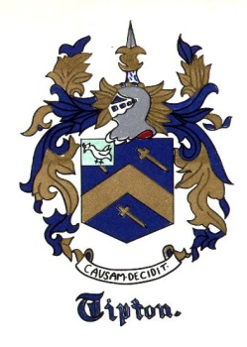

Tipton Family Association of America

Save the Date
Event: Tipton Family Association of America Annual conference and Reunion

Date: October 27, 28, and 29, 2023

Location: Woodstock VA/ Shenandoah Valley VA

Notes: The 2023 TFAA Conference and Reunion is still several months away and God willing we will be able to get together learn many things and meet many new family members.

We are working on Hotel, dining, transportation etc. and will update you ASAP

SAVE THE DATE!!!!!!!!!!!!!!!!!!!!!!!!!!!!!!!!!!!!!!!!!!!!!!!!

NEWS

Obituaries

Sherman Allen Tipton
November 26, 1959-January 31, 2023
Sherman Allen Tipton 63 of Rogers passed away January 31, 2023 at the Veterans Hospital in Fayetteville, Arkansas. He was born November 26, 1959 in Hugo, Oklahoma the son of Selby Brandner and Mary Lou Stanphill Tipton. He worked for MCH Kenworth for about 18 years as a truck salesman, parts manager, and branch manager. In retirement he loved driving around in his car and watching NASCAR races. Allen serves in the United States Navy for 10 years and was active in Alcoholics Anonymous, Celebrate Recovery, and the American Legion. Preceded in death by his parents.
He is survived by his children Ashley Tipton and Joshua Bachler and wife Kristine; two step grandchildren Jordan and Jayden Bachelor; his sisters Brenda Kay Robertson and Linda Henry and husband WT Henry. Many other loved nieces and nephews.
Funeral services 2:00 p.m. Saturday; February 4, 2023 at Benton County Funeral Home, 306 N. 4th, Rogers. Interment with military honors in the Rogers Cemetery. Visitation 5:00 to 7:00 p.m. Friday at the funeral home. Online condolences to www.bentoncountyfuneralhome.com

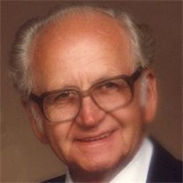
James Roy Tipton

May 24, 1924 — August 19, 2013

James Roy Tipton of Maryville, Tennessee, born Saturday, May 24, 1924 in Fontana, North Carolina, passed away August 19, 2013 at the age of 89 at Parkwest Medical Center. He was the son of the late Rev. Jim F. Tipton and Mrs. Julia K. Messer Tipton. Born and grew up in the beautiful Smoky Mountains of North Carolina, along the shores of Little Tennessee River and Cheoah Lake, between Tapoco and Fontana, NC. He was known in the community, school, church and in his home, where he grew up as James Roy, that is what people still call him today that knew him back then. He attended school at Rymers Ferry, near the Santeetlah Powerhouse on the banks of Cheoah Lake, where his father worked. James professed religion at the age of 12 and was baptized in the Little Tennessee River, near where he was born at the site where Fontana Dam was built, and after he grew up that's where he got his first job as an employee of T.V.A. helping to build the dam.

Some of his fond memories were that as a child growing up close to the river and lake, hunting, fishing, outdoor life. He recalled a conversation with his father while they were fishing from a small boat. His father told him about a large ship called the Titanic, a ship so big that people could ride bicycles on it. This was hard for him to believe. Art was his favorite in school and he loved to draw ships, not knowing he would ever see one or ever be on one. During World War II, he joined the United States Navy, and served aboard a destroyer escort which crossed the Atlantic Ocean four times, between the United States and Europe and North Africa, this was before Normandy Invasion on June 6, 1944. On April 20, 1944 his ship the USS Fechteler came under heavy enemy air attack, five ships of the convoy that his ship was helping to escort, was torpedoed with the loss of over 600 lives. Less than two weeks later on May 5, 1944 his ship was torpedoed by a German submarine in the Mediterranean Sea, and sunk with the loss of 29 of his ship mates. James Roy was one the 26 that were wounded, he was among that last to be saved from the sinking ship. He was knocked out by the explosion of the torpedo. He recalled when he came to there was no one around him. He was wounded with several injuries, bleeding from the nose, mouth and ear. His back was hurting so bad that he could not stand up. It was night and just the moon light to see by, he thought he was the only one left on the ship. He tried to crawl to the side of the ship so he could get into the water and try to swim away. He managed to get from an upper deck to a lower deck, this is where he thought he was going to die, weak and hurting with water coming up around him, he started to pray, as a boy of 19 years old, he was afraid that death was near. All of a sudden a voice from Heaven said "Don't be afraid." Then the fear of death left him and as the water was about to cover him a shipmate called to him and said we are coming to get you. God must have sent those sailors back to rescue me, he stated. James Roy spent over a year in Navy Hospitals, with several operations on his back trying to recover from his wounds. While hospitalized he saw a lot of injured veterans suffering and dying. He made a promise, if God would let him live he would never forget them and he would always honor war veterans as long as he lived.

After being discharged from the Navy he came to live here in Maryville, met a beautiful girl, Barbara Joyce Hancox who would become his wife. The happiest day of my life was when I married Barbara on December 11, 1946. She bore two wonderful children for me, Steve and Pamela. James Roy completed a commercial art course at Stair Tech School, Knoxville, TN completing training with outstanding grades. He operated his own sign business until retirement in 1985.

Some of James Roy Tipton's accomplishments and honors include: his name is permanent in the United State Patent Office, Washington, D.C. in 1962 he was issued a U.S. patent for a sign devise that he invented; he is a charter and life member of The DAV, Disabled American Veterans, Chapter #76, that he helped to organize in 1955; in 1975 he became the State Commander of DAV Organization and was awarded Commander of the Month for five consecutive months by the National Commander, no one else has ever received that honor in Tennessee; in 1966 he organized the United Veterans of Blount County (Life Member); he organized the M.O.D.H. military order of the Purple Heart Sam Houston Chapter 1814, which he is a charger and a life member; he is a life member of the V.F.W. (Veterans of Foreign Wars) Post #5154; a member of the American Legion Post #13 for 34 consecutive years; a life member of the National D.E.S.A. (Destroyer Escort Sailors Association); a member of the National Order of the Trench Rats, a branch of the DAV; an honorary life member of the Patriotic Order Sons of America; an honorary Tennessee Colonel; an honorary Kentucky Colonel; an honorary Alabama Colonel; of all his memberships, he is the most proud of being a member of the Broadway Baptist Church here in Maryville. He said without God nothing else matters on this earth.

Down through the years his art work has been viewed by millions and his art will be viewed in the future. In 1964 he designed the Blount County War Dead Monument, which sets on the courthouse lawn here in . . . Maryville. In 1980 he designed the Tennessee Civil War Monument which now sets on the famous Civil War Battlefield at Gettysburg, PA. James Roy said, "I would like to thank God for allowing me to be born, and giving me a wonderful life. Sometimes it seems as if God created everything for me. He put all those wonderful people on earth so I could live with my parents, brothers and sisters and all of my relatives, my wife and children and all of her relatives, those church and religious people who gave me faith to believe in God, all the people who served our country during war and gave their lives so we may have this precious freedom, my friendly neighbors and all the other great people that I met during my life span. I have tried to be honest, faithful and dedicated and if I succeeded in any of this I owe it all to God." James also said, "When the doctor told me I had cancer I prayed to God and I said why me? Then I tried to think of how many times down through the years that God did save my life, but I could not remember all of them. So I said God I am in your hands." I would like to dedicate my life to the one person that stood by me through all of our marriage life, who never laughed or made fun of my handicap, instead she gave me comfort and moral support. She was always there when I needed her. Barbara I love you.

James was preceded in death by his Sisters- Elizabeth (Tipton) Rogers and Sally Tipton Brothers- Arthur Tipton, Ardell Tipton, Boyd Tipton, Luther Tipton, Joe Tipton, Prince Sluder and John Sluder. Survived By: Son & Daughter-in-law Stephen and Cindy Tipton of Maryville, Daughter and Son-in-law Pamela and Daniel Webber Jr. of Corryton, Grandchildren: Bill, Jim, April, Rebecca, Jason and Justin. He was also survived by 8 Great Grandchildren and 4 Great Great Grandchildren. In Memory of James Tipton donations can be made to Blount County War Dead Memorial Restoration Fund through The United Veterans of Blount County Service Office 865-273-5760 or The Military Order of Purple Heart through Sam Houston Chapter 1814 website: http://www.purpleheart.org/. . . . Smith Funeral & Cremation Service, Maryville, 865-983-1000.

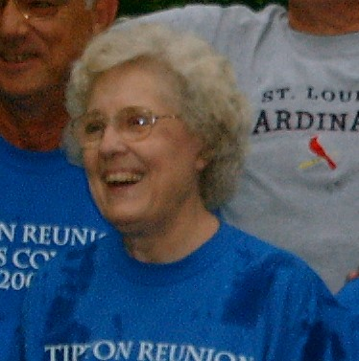
Mary Viola Tipton Etter

January 6, 1930-December 20, 2022

On December 20, 2022 Mary Viola Tipton Etter passed away saying goodbye to this world to make a grand entrance through the gates of Heaven to be reunited with those loved ones who are joint heirs with Jesus Christ their Savior. Mary was born on January 6, 1930, to Milton and Hazel Lohmeyer Tipton in St. Louis, MO, the second of 7 children.

When Mary was in high school two friends kept inviting her to St. Louis Park Baptist Church. She finally agreed and at a revival service Mary had a personal experience with the Lord Jesus Christ and asked him to be her Savior. Throughout her life she continued to be a devoted follower of Christ. In her last years she enjoyed being a member of Heritage Baptist Church in Bolivar, MO.

During her first year of college at Southwest Baptist College in Bolivar, MO she met Guy Etter and they married on July 29, 1948. They were married for 62 years and together were blessed with five children.

Mary supported Guy’s ministry for the Lord by teaching Sunday School, leading Vacation Bible School, taking a leadership role in the Women’s Missionary Union, and singing in the church choir. Giving to various ministries that were very dear to her heart was of great importance to her whether it was the local Alpha House, missions through her church such as the Lottie Moon Christmas Offering and many more state, national and worldwide ministries.

One of her goals was to encourage her children in their education along with school and personal activities including sports, art, and music – both instrumental and vocal. She was very proud of her family and their accomplishments.

She returned to college as an “older student” at Missouri Southern in Joplin in the early seventies to complete a degree in Elementary Education. She taught at many schools due to Guy pastoring several small-town churches throughout Missouri. She retired from her final position as a Second-Grade teacher in Collins, MO. Although she lived in many towns in Missouri, she always considered herself a St. Louis girl and a fan of her hometown Cardinals.

One of her joys was gardening. The garden helped her provide her family with delicious vegetables throughout the year. Her many flower beds were a delight to her to see them thrive again each spring. She always shared flower bouquets with her neighbors in the Spring and Summer, with neighbor girls helping in the delivery. Her yard was alive with color from the beautiful roses, irises, daffodils, and her favorite dahlias.

She prided herself in teaching her daughters how to cook and sew. She was quite the seamstress with sewing both of her daughter’s wedding dresses. Quilt making was another passion she had. She enjoyed being a member of the Sew “N” Sew Quilt Club in Bolivar, MO and the friends she made there. She made quilts for many family members. She taught her sons how to do laundry and clean because boys needed those life skills as well as girls. She stressed to her sons the importance of being caring and supportive husbands to their wives.

Mary was known for her saying that she would just “go with the flow” when plans were being made for different family activities. We decided she went with the flow unless the flow wasn’t going in her direction! It always worked out in the end though.

Mary was preceded in death by her parents, Milton and Hazel Tipton; her husband, Guy Etter; her daughter Joyce Etter; and her brothers Don Tipton and Melvin Tipton. Mary is survived by her children, David Etter and his wife, Terresa of Williamsburg, KY, Becky Diesel and her husband, Marion of Bolivar, MO, Marty Postel and her husband, Bruce of Raytown, MO, and Paul Etter and his wife, Jeanne of Robinson, TX. She is also survived by her siblings Lillian Roslawski of St. Clair, MO, Ed Tipton and his wife, Carole of St. Charles, MO, Bill Tipton and his wife, Carol of Silver Springs, MD, and Dan Tipton and his wife, LaVohn of King George, VA. Mary is also survived by 10 grandchildren, 27 great-grandchildren, 1 great-great grandson and many nieces and nephews.

Although Mary adored flowers, we are quite certain that God will bless her with beautiful gardens at her home in Heaven. The family is asking in lieu of flowers to please send a donation to the Alpha House Pregnancy Resource Center, PO Box 644, Bolivar, MO 65613.

Interment will be at the Missouri Veteran’s Cemetery in Springfield on Friday morning. The family wishes to thank everyone for attending today to help celebrate our Mom, Grandma Mary, as she celebrates her new home in Heaven with Jesus.

FEATURES

Yes, There Is a Tipton, England

by Reba Carolyn Rhyne Meiller

My first trip was in 2018 for the Canal Festival in September. A group from the Tipton Family Association of America went. There was a lady from California, Robert, Mary, and Ashley Tipton from Maryland, and myself, Donna Gregory and Donna’s friend all from Blount County, Tennessee.

Imagine flying in alone to Birmingham Airport, boarding a train for Tipton Station, and meeting a man I’d only e-mailed to discover a village where my ancestors once lived. Mr. Worsey had texted he might be a little late getting to the Tipton Depot, and he was, but not much.

He and I immediately walked over one of the many narrow canals found in Tipton, which led to its nickname, “The Venice of Tipton.” The library on Owen Street is one of three in the area, and we headed there. It’s upstairs off Tipton Shopping Centre. Everyone is very helpful and the breakroom is full of books for me to look at, since I’m after some background on the first Tipton to America, Jonathan I as we call him. Imagine my astonishment when I’m given information that I can go back many centuries, and soon I’m reading about the tribal chief, Tybba, who the town is named for. That’s another story.

Tipton today is a very busy place with lots of traffic. I stayed at the Travelodge, which is in walking distance of three important places found in Tipton—The Black Country Museum, The Dudley Zoo and, of course, McDonalds. Ha. A couple of blocks walk and around the corner and you’ll come to Dudley Canal Trust—a water ride through a tunnel under Castle Hill.
Travelodge

The Black Country Museum is the Dollywood of Tipton without the rides. It’s a five-minute walk from the Travelodge where I stayed. The museum depicts life as it was in the 1800’s and early 1900’s, when coal and steel were kings of the area. This black coal lay on the surface in some places and just below the surface in others. When the American Ambassador, Elihu Hewlett, visited the area he exclaimed, “Black in the day and Red at night.” He was talking about the coal smoke which coated everything in the daytime and the flaming fires of the blast furnaces forming steel at night. Those days are gone, but you will feel their effects as you visit homes, schools, stores, and other areas, where you can talk to people clad in the clothing of the time period.
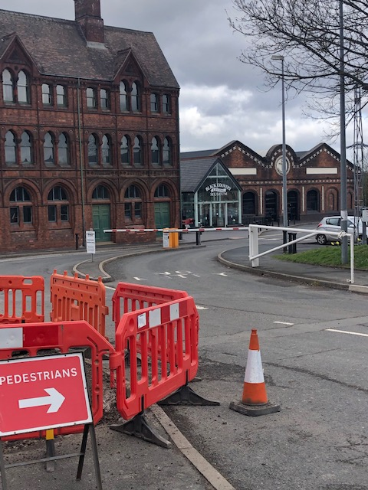Black Country Museum
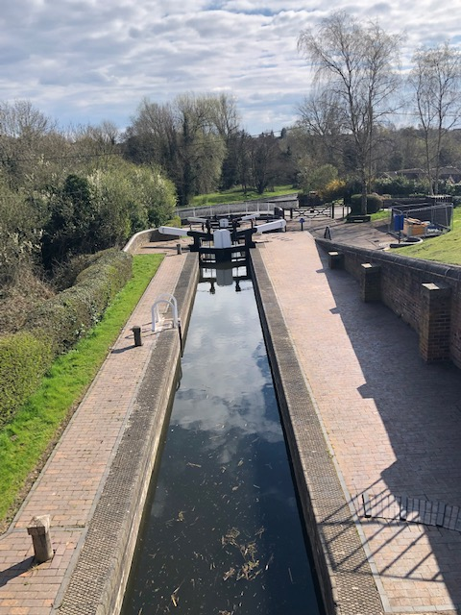Bratch Locks

Once the products were cast or made in the forge, they were loaded on narrow boats and shipped as far as London. Tipton was once known as the “Venice of Tipton” because of its thirty miles of canals and locks. The locks, such as Bratch Locks, raise or lower the water much like our TVA locks do to move boats around the lakes.

If you walk for any length of time such as on Owen Street where the Tipton Library makes its home, you will come to Tipton Green, a park area where a canal runs to the side of it and you will see a statue of the famous champion Tipton Slasher. The Slasher was England’s bare-knuckled fighter.

There are roundabouts typical of England and plenty of cars buzzing around them. Tipton was once one of the richest and most industrialized places in the country. After the coal mines and steel industry stopped, you now find many places with To Let signs.
There are many places to eat, and no I didn’t go to Mickey D’s. Several places known for great food are The Harvester, a near walk, or Andy’s Fish and Chips, close to the library, or if you want to sample a famous maker of pot pies, Mad O’Rourke’s will accomplish this. These aren’t the only great eateries, but they are the ones I ate at.
A short drive away, there’s Himley Hall with its ghosts and grounds. This is where the Prince of Wales, Edward, who abdicated the throne to marry Wallis Simpson entertained his mistresses, and where many mysterious meetings took place with his acquaintances. Let’s just say Edward and Wallis were weird. If you want to know more, go online and ask.
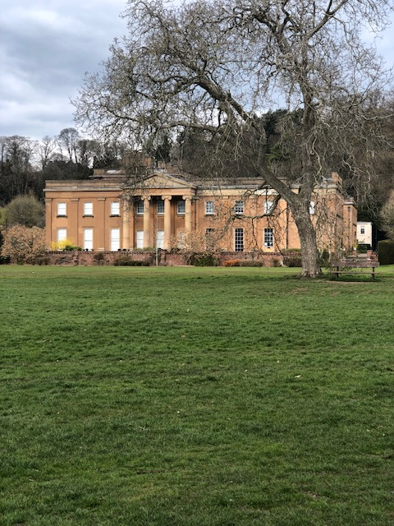Himley Hall
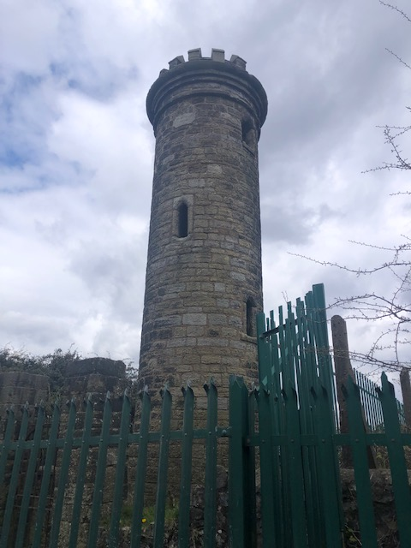Sedgely Beacon

One can also visit the round, stone Sedgely Beacon. The beacon was among the ones lit when the Spanish Armada was spotted coming into the English Channel. The light warned the English in each shire of their approach with the need to get their arms ready. The lights were lit from highest hill to highest hill. They were also lit at Queen
Elizabeth’s Jubilee in 2022. Going on up the hill by the beacon gives one the impression of the area around Tipton, one rolling hill after another.

Also, a short drive is the Priory, now only a ruin. This was once a church and a school for boys. It’s been converted into a playground and picnic area—a great place to take a stroll.
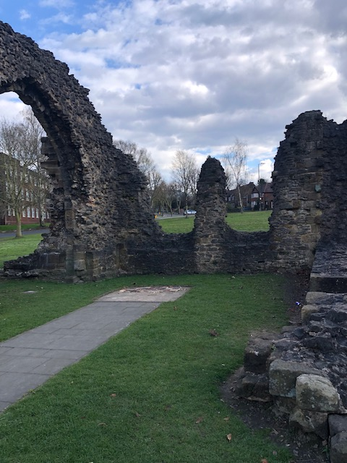Saint James Priory
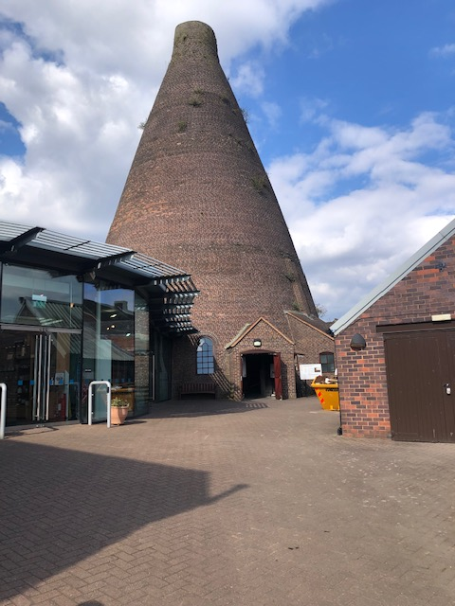Red House Glass Cone

There were 6 or 7 conical furnaces which melted materials to make glass called, of course, Glass Cones. There is only one left for visitors to tour.

The ruins of the famous Dudley Castle sits on top of the hill behind the Travelodge. You can see its spire from the parking lot, and Dudley Zoo inhabits Castle Hill. The zoo and castle can be seen on one ticket by walking across the parking lot from the hotel.
Tipton is worth going to see, and I recommend it. Since we had a very able man to show us the ropes, I suppose one could rent a car and buy a map. Just remember the English drive on the wrong side of the road.
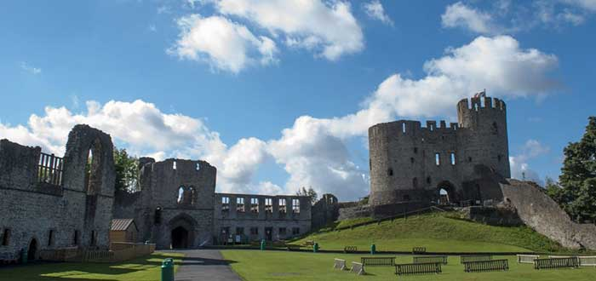Dudley Castle and Zoological Garden
Reba Rhyne (Reba Carolyn Rhyne Meiller) 2022 Reunion at Franklin, Tennessee

**I have 9 books with Tiptons in them and I’m working on number 10 which will chronicle Col. John Tipton and William “Fightin” Billy Tipton.
The two books, The Tipton’s of Tybbington, came out of my trip to England. Two years in writing, you’ll find out what our ancestors went through and you’ll meet Tybba, whom the town is named for. The book was edited by my friend at the library, and I feel the commentary is as correct as an American can write about English history. All on Amazon.com/rebarhyne

I plan on visiting Seville, Spain in March and walk in the footsteps of Hugh Tipton, appointed first as consul of the English government by Henry VIII and then Elizabeth I. Even the King of Spain knew him and called him an honorable man.

Our Other Famous Tiptons

Part Two
by David Etter

(Adapted from the presentation made on Sunday, October 9, 2022 for the TFAA Reunion/Conference)

Continuing our look at other famous Tiptons we turn to those who specifically signed up for military duty and excelled in their chosen profession. I have chosen three men who are prime examples of the Tipton dedication to service to one’s country. There are, of course, others who could be mentioned, but let us focus on these three for now.

COL. WILLIAM DOLLEY TIPTON (1892-1945)
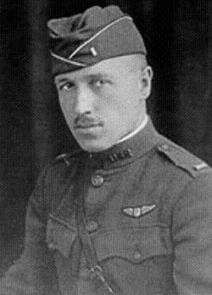
William Dolley Tipton was born to Alfred Slade Tipton (1850-1919) and Mina Jane Duncan Tipton (1859-1940) in Jarrettsville, MD. He married Elizabeth Barrett (1886-1967). Tipton’s military career began on 5 June 1917, when he enlisted as a private first class and entered training as a flying cadet. As a cadet, he attended flight training at Ohio State University's School of Military Aeronautics and later trained at the British Royal Air Force training brigade at Oxford University in England. On March 9, 1918, he was commissioned as a first lieutenant in the Aviation Section of the U.S. Army Signal Corps and was one of the American pilots forwarded to Britain’s Royal Flying Corps for advanced training and combat seasoning. The Royal Flying Corps was joined with Royal Naval Air Service to create the Royal Air Force in April 1918.

According to some sources, he won his first two air battles in May 1918, while attached to the British No. 3 Squadron. Rejoining the American 17th Aero Squadron on 21 June, he became a balloon buster on 22 August 1918. Four days later, he destroyed two Fokker D. VII in a late afternoon dogfight, but was also wounded and shot down, most probably by Leutnant [sic] Hermann Frommherz (one of Germany’s ace pilots). Tipton spent the rest of the war as a prisoner of the Germans. He was awarded the British Distinguished Flying Cross during the war.
The U.S. Air Force aerial victory credit register does not include the two alleged victories from May. It does corroborate Tipton's last three victories. Tipton flew his first combat missions in May 1918, so it is possible that he did indeed score the two victories the U.S. Air Force does not credit to him. With five aerial victories rather than four only, this would qualify him to be a flying ace.
The lure of flying proved irresistible and on Aug. 18, 1919, he returned to the military as a member of the Air Corps Reserve. At the same time, he was working as the "staff aviator" for the Evening Sun in Baltimore, the first American newspaper to use aircraft to gather news. In this role he was employed as both a pilot and the author of a regular aviation news column.
In March 1921, Tipton was one of five Air Corps Reserve officers involved in the initial meeting that led to the creation of what would become the Maryland Air National Guard. On June 29, 1921, the 104th Observation Squadron was federally recognized and Tipton officially became a Maryland National Guard officer.

Tipton would go on to play other important roles in the nascent Maryland aviation industry. He served on the State Aviation Commission, which studied aviation conditions in Maryland and recommended legislation to promote aviation within the state, from 1921 to 1928, and leased and ran the Curtiss-Wright aviation facility northwest of Baltimore during the 1930s and 40s.
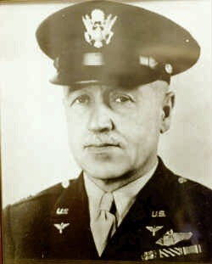
By the time of the Maryland National Guard's mobilization for World War II on Feb. 3, 1941, Tipton had reached the rank of lieutenant colonel and had served in a variety of capacities, including commander of the 104th Observation Squadron and Division Air Officer for the 29th Infantry Division.
During the war, Tipton attained the rank of full colonel and the rating of command pilot. On Dec. 12, 1945, the P-47 he was flying crashed near Adena, Ohio, killing him. At the time of his death, Tipton was assigned to the 204th Army Air Force Base Unit in Texas.

In 1962, Tipton Army Airfield at Fort Meade, Md., was named in his honor. In 1995, the facility was transferred to civilian control and in 1999 it became operational as Tipton Airport in Anne Arundel County.

William Dolley Tipton is buried at Arlington National Cemetery.

Genealogy of William Dolley Tipton: Father, Alfred Slade Tipton (1850- 1919); Grandfather, William Bowen Tipton (1822-1880); Great Grandfather, Solomon Bowen Tipton (1793-1860), 2nd Great Grandfather, Samuel Tipton, Jr. (1753-1817), 3rd Great Grandfather, Col. John Tipton (1730-1813)

Sources: Ancestry.com, wikipedia, findagrave.com, web article by Capt. Wayde Minami, 175th Wing Public Affairs

MAJOR GENERAL JAMES BAIRD TIPTON (1915-1995)

James Baird Tipton was born in Senath, Missouri, 2 February 1915 to Paul Light Tipton and Hettie N. Baird Tipton. He graduated from Blytheville High School in 1933 and from the University of Alabama in 1938 with a bachelor of science degree in Aeronautical Engineering.
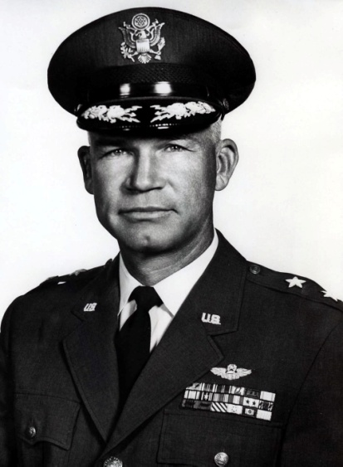
He was commissioned a second lieutenant in the Corps of Engineers Reserve through ROTC while still in college. He entered flying cadet training at Randolph Field, Texas, in July 1938 and received his wings at Kelly Field, Texas, in May 1939. Three months later he was awarded his regular commission. In June he returned to Randolph as an instructor pilot and remained with the rapidly expanding pilot training program until October 1943. During this period he supervised contract flying schools at Dallas, Brady and Ballenger, Texas.
His next assignment was with the 366th Fighter Bomber Group in England where he served as deputy commander. In April 1944 he assumed command of the 363d Fighter Group and later the 358th Fighter Group. During this time he flew 93 combat missions in P-47 and P-51 aircraft.
In July 1945 he accompanied the 358th back to the United States for re-equipage at LaJunta, Colo. The 358th was deactivated at the end of the war and he was reassigned to the Tactical Division of the Army Air Forces Board at Orlando, Fla.
He remained with this unit on its move to Maxwell Air Force Base, Alabama, in mid-1946 where it became the Evaluation Division of the Air University. He left there in September 1947 to enter the Armed Forces Staff College. Upon graduation in 1948, he returned to Maxwell to become Tactical Operations Instructor at the Air Command and Staff School.
Although appointed to the 1950 class of the Air War College, the outbreak of the Korean War cancelled this class and in August 1950 he was assigned to the Far East Air Force Headquarters in Japan as war plans officer.
Early in 1951 he assumed command of the 8th Fighter-Bomber Wing at Itazuke Air Base, Japan, which moved into Kirripo Air Base (K-14), Korea, in April, and into Suwon (K-13) in September. During this period he flew 38 combat missions over North Korea in F-80 and F-84 jet fighters.
Returning to the United States in April 1952, he became assistant deputy chief of staff for operations at Tactical Air Command Headquarters at Langley Air Force Base, Virginia.
In 1954 he entered the National War College, Washington, D.C., and graduated a year later. He was then assigned to Headquarters, U.S. Air Force, as chief, long range objectives, in the Office of the Deputy Chief of Staff for Plans and Programs.
In 1958 he once more returned to Japan where he assumed command of the 3d Bomb Wing at Johnson Air Base. He was promoted to brigadier general on June 23, 1959 and two weeks later appointed commander of the 314th Air Division, Osan Air Base, Korea. Upon completion of his assignment in Korea, General Tipton was cited by the Republic of Korea with the Order of Military Merit Taegak in recognition of his leadership and active cooperation in the air defense of Korea.
In July 1961 General Tipton returned to the United States and assumed command of the Washington Air Defense Sector at Fort Lee, Virginia.
In July 1963 General Tipton was promoted to major general and assigned to U.S. Strike Command as Deputy Director, U. S. Strike Command Joint Test and Evaluation Task Force, MacDill Air Force Base, Florida.
On Aug. 1, 1964, General Tipton assumed command of the 32nd NORAD/CONAD Region/Montgomery Air Defense Sector, Gunter Air Force Base, Alabama. The mission of the 32nd Region is to protect a seven-state area in the Southeast U.S. against aerospace attack.
In November 1966 General Tipton was assigned as Commander, 6th Allied Tactical Air Force Detachment 5, Izmir, Turkey.
General Tipton [was] a command pilot with more than 5,000 flying hours. His decorations include the Legion of Merit with two oak leaf clusters; Distinguished Flying Cross; Bronze Star; Air Medal with 15 oak leaf clusters; British Distinguished Flying Cross; Belgium Croix de Guerre with Palm; French Croix de Guerre with Palm, World War II Victory Medal; Korean Service Medal; United Nations Service Medal; and Korean Eulchi Distinguished Military Service Medal with silver star.
General Tipton moved to Lake Placid, Florida about 1985 with his wife, Anna. He died 29 March 1995 in his home in Lake Placid.
Genealogy of James Baird Tipton (1915-1995): Father, Paul Light Tipton (1880-1971); Grandfather, Pleasant Lawrence Tipton (1849-1912); Great Grandfather, Pleasant M. Tipton (1812-1875); 2nd Great Grandfather, Jonathan Tipton (1776-1858); 3rd Great Grandfather, Col. John Tipton (1730-1813)
Sources: Ancestry.com, Newspapers.com, and <https://www.af.mil/About-Us/Biographies/Display/Article/105418/major-general-james-b-tipton/>

BRIGADIER GENERAL CARL W. TIPTON (1935-1993)

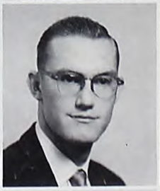
Carl W. Tipton was born in Manilla, Arkansas on 27 February 1935 to John William Tipton and Flora Mae Stutts Tipton, married Shirley Sanders in 1957 in Yellville, Arkansas, and died 3 December 1993 in Prince William, Virginia and is buried in Arlington Nation Cemetery.
Tipton graduated from the University of Arkansas in 1957, enlisted in the U.S. Army in July 1958, and received a Master's Degree in Logistics Management from the Florida Institute of Technology in 1979. After serving with the Materiel Development and Readiness Command from 1979 to 1982, he commanded the 13th Support Command, III Corps, Fort Hood, Texas. In 1985, he was assigned as Director for Maintenance, Tank-Automotive Command, and in 1986 became the Deputy Commanding General for Procurement and Readiness.
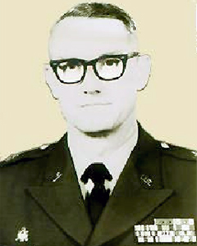
His final assignment was as Commanding General, 200th Theater Army Materiel Management Center in Europe from 1989 to 1991. There, he facilitated logistical stability during the turbulent period following Germany's reunification and the collapse of the Warsaw Pact. He developed the transportation plan for the retrograde of tanks, armored personnel carriers, and howitzers, and realigned the theater reserve stocks to ensure the continued combat readiness of residual U.S. forces.
During the deployment of forces to Southwest Asia, he provided $960 million of equipment and spare parts to deploying units from theater logistical reserves, acquired $5 million of transport equipment to support the deployment, and moved more than 200,000 short tons of ammunition to the theater of operations within 90 days.
General Tipton retired in 1991 and died in 1993.
Genealogy of Carl William Tipton (1965-1993): Father, John William Tipton (1910-1980); Grandfather, Carl William Tipton (1888-1971); Great Grandfather, Claiborne William Tipton (1861-1888); 2nd Great Grandfather William Henry Tipton (1832-1919); 3rd Great Grandfather, Samuel Jackson Tipton, Jr. (1803-1863); 4th Great Grandfather, Samuel Tipton (1777-1861); 5th Great Grandfather, Jonathan Tipton III (1750-1833) and Keziah Sevier; 6th Great Grandfather, Jonathan Tipton II (1699-after 1796)

Sources: Ancestry.com, findagrave.com, <https://prabook.com/web/carl_william.tipton/655961> <https://goordnance.army.mil/hof/1990/1993/tipton.html>

Next time in Part Three: One more politician that I forgot to include this time and some professional sports figures. And a few professionals in the arts, if we have room.

MEMORIES AND TALES

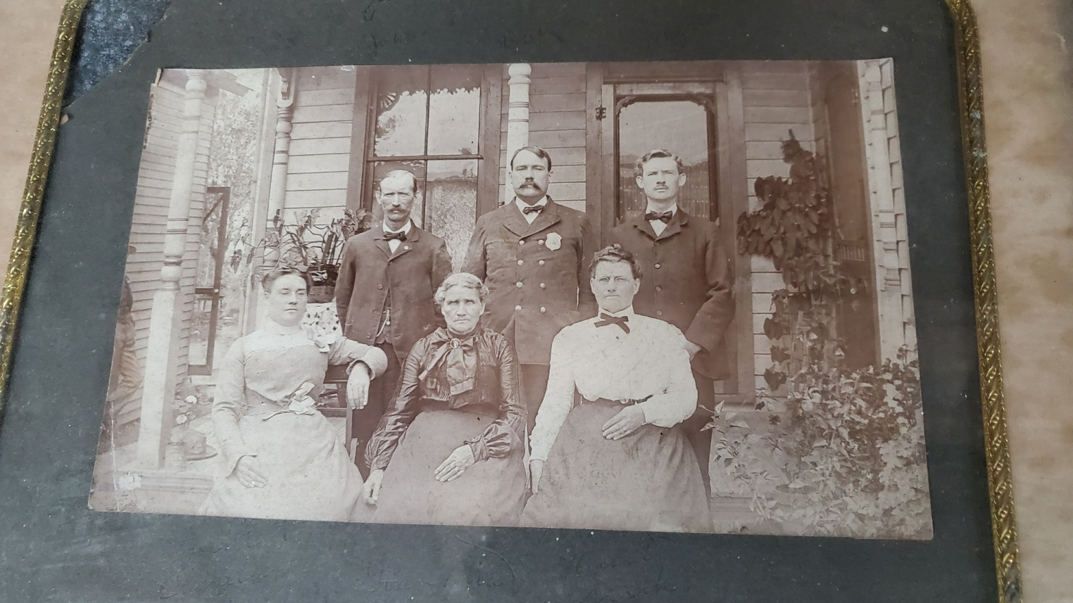
This is Nancy Vance Tipton, wife of Wiley Tipton who was a veteran of the Civil War. Camilla is on the left with a flower at her waste, Nancy is in the middle bottom row, and Sarah has a ribbon tied at her neck. Behind her in the second row is my great grandfather, Alfred Tipton. Beside him is Dave or David. My grandmother, Helen Tipton Slaughter, thinks the man behind Camilla is John Tipton. Nancy is dressed in black which makes me wonder if they have been to a funeral (perhaps Wiley's). I have some great stories about Nancy Vance Tipton and Wiley which I hope to share when I have more time to write it all down.
Annie Warmke
<annie@bluerockstation.com>

[Note from the editor: We welcome interesting stories and pictures of every kind that our members and readers have to share about Tiptons and their “doins.”]

QUERIES

Hello David,

Greetings from wintery Massachusetts.
I am trying to find any clues as to my Cherokee heritage.
My maternal grandmother, Mary Jane Tipton was born (Jan.30, 1876) in Cades Cove in the Smokies, then lived in Knoxville. She and grandfather Jacob Tipton(1867-1931) had ten children; my dad, Chester H. (Jan.24 1896-1968), was second in line.

. . . . I am hoping with all those Tiptons that there will be someone who has some information.

Thanks and Happy Year of the Rabbit!
May you have an abundance of Blessings,

gail tipton
<gtip@ix.netcom.com>

_______________________________________________________

The newsletter of the Tipton Family Association of America is a quarterly online publication that encourages submission from members to share results of their research into Tipton family lines, stories and pictures of ancestors, news of events that feature Tiptons or Tipton history, and other usefull and interesting information about Tiptons.

