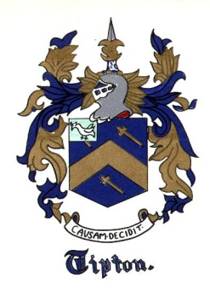
The Tipton Family Association
of America Newsletter

The Tipton Family Association of America
3236 Forum Blvd # 1075
Fort Myers, Fl 33905

WINTER 2022

PRESIDENT COMMENTS

Hello family, I hope all is well and happy.

First of all welcome to all new members and to our new Editor David Etter.
You may notice that over the past few months we are making some changes in an effort to move forward and get back to the original intent of the TFAA. Of course we must make some changes in order to keep up with the times!
TFAA is meant to be an information and research sharing association as well as bringing our Tipton family together. If you have family or research information that you wish to share please send it to us at Daviddetter70@gmail.com or TFAA2019@comcast.net

IS YOUR TREE CORRECT?
Over the past few months I and others have found INCORRECT information in trees, including my own. We find information in someone else's tree and attach it to our own. There are books written on or about our family and, unfortunately, some of the information in these books is also incorrect. Please check and double check all information before entering it.

Two examples:
1. A document was found in a tree and in reading it the actual document shows the Tipton Father and his grandson (same name) married the same 3 ladies. I'm pretty confident that this information is incorrect.

2. In other trees folks have listed Colonel John Tipton as the ancestor and in reality the ancestor was General John Tipton. General John Tipton was born in 1786 in Sevier County, Tennessee. He is the great nephew of Colonel John Tipton. General Tipton moved to Indiana in 1807, became a brigadier general with the Indiana militia, and served in the Indiana House of Representatives. He died in 1839.
The Annual Conference is scheduled for October 7, 8 and 9 around the Nashville, TN area, TBA. Keep watching your email and our FB page for more information.

Have a Blessed Season

Kathy Hoffmann
TFAA President
239.994.1246
peachyrose56@gmail.com

TFAA Committee
President – Kathy Hoffmann
Co-President – Kathy Brewster Price
Treasurer – Vacant
Secretary – Cathy Tipton Lowe
Communications Director – Charles Tipton (aka Junior)
TFAA Tipton Research Director – Charlotte West Dade
Tipton Family DNA project Administrators – Bob Tipton and Bonnie Grant
Editor – David Etter <daviddetter70@gmail.com>

TFAA RESEARCH DIRECTOR, CHARLOTTE WEST DADE

On December 15, 2017, I started the Tipton Family Research Group in Facebook. Prior to starting the Facebook site, I requested and received permission from the Tipton Family Association to start the group. As the owner of the group, which is part of my personal account in Facebook, I am designated as the administrator of the group. Currently, the Tipton Family Research Group consists of 287 members with the numbers varying as additional members are added.
In order to become a member of the research group, those requesting membership must provide the beginnings of a lineage, such as the names of his/her parents, grandparents, and great grandparents. The inclusion of any additional generations is very helpful. This information gives me enough information to research the lineage.

When I started the Facebook group in 2017, I did not research the lineages of the new members. In order to be genealogically correct, I began researching the lineages of all new members and working on the lineages of those earlier members as I am able. Once the research is complete, I send to the member the lineage that has been determined by documentation and a list of the sources used to prove the lineage.

My credentials as a researcher are based on my experiences as registrar of my chapter of Daughters of the American Revolution (NSDAR). I have served this in this capacity the past 6 ½ years researching and documenting the lineages of prospective and current members. In addition, I have completed four courses in lineage research with the National Society of Daughters of the American Revolution.

Recently, I was honored to be designated as the TFAA Research Director.

NEWS

Battle of the State of Franklin
February 27-29, 1788
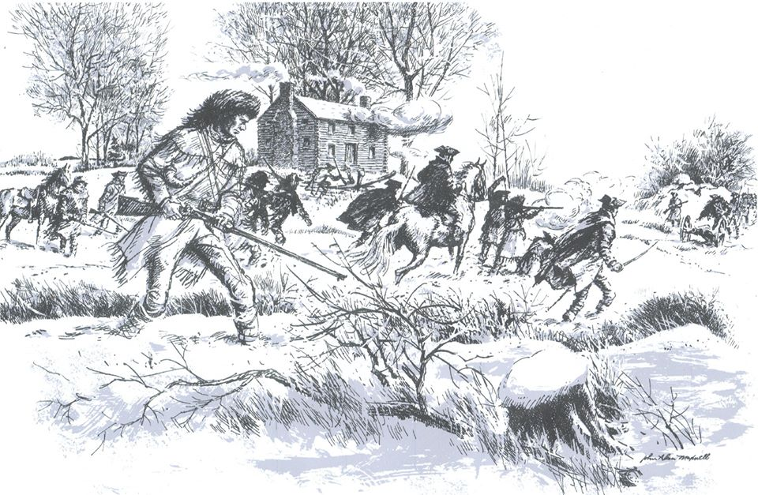
Tipton-Haynes Association charter member John Alan Maxwell’s depiction of the battle fought at Colonel John Tipton’s cabin.

February 26, 2022 - Schedule of Activities
9am – site opens to visitors
10:30am – showing of The Mysterious Lost State of Franklin documentary (in visitor center)
11:30am – artillery demonstration (near barn/corn crib)
12pm – small arms demonstration (near barn/corn crib)
12:30pm – showing of The Mysterious Lost State of Franklin documentary (in visitor center)
1:30pm – brief introduction of the 1788 battle (near barn/corn crib)
2pm – recreation of the Battle of the State of
Franklin (near barn/corn crib)
* The Tipton-Haynes house will be open all day for visitors to tour on your own *
Admission is $5 for adults and $2.50 for children twelve and under.
Tipton-Haynes members are free!
Tipton-Haynes Historic State Site
2620 S. Roan St., Johnson City, TN
Tipton Family DNA Project Report

The Tipton Family DNA Project originally began as a way to determine if and how the Thomas Tipton who resided in Burke County, Georgia, from 1785 to 1820 connected to the Tiptons who descend from Jonathan Tipton who died in Baltimore County, Maryland, in 1757.
The project officially began 25 August, 2004, with Bonnie Tipton Grant, Mitzi Bateman, and Charles D. Tipton (author of TIPTON: The First Five American Generations) as Co-Administrators. In 2008, Bob Tipton joined the team as a co-administrator after the death of Charles.

The project web site is hosted by the DNA testing company FamilyTreeDNA (FTDNA) and can be found at https://www.familytreedna.com/groups/tipton/about/background. Most of the pages at this site are available to the general public although certain pages, such as the Activity Feed, are available only to project members.
DNA 101

DNA (short for Deoxyribonucleic acid) is a long molecule which happens to be made up of only four simple building blocks, known as nucleotides. These nucleotides are known by their chemical names but are usually referred to by the first letter of these names: cytosine (C), guanine (G), adenine (A), and thymine (T).
The easiest way to picture a DNA molecule is to think of a ladder. The rungs of the ladder consist of two nucleotides bound together. Due to the chemical nature of the nucleotides, a C will always bind with a G, and an A will always bind with a T. The bound pair that forms a rung of the ladder is usually referred to as a base pair.
We are normally concerned with two types of DNA molecules. The first type forms long strings known as chromosomes. These chromosomes are located within the nucleus of each cell. In a human being, the cell contains a total of 46 chromosomes with a total of about 3 billion base pairs. These chromosomes come in pairs, so there are 23 chromosome pairs. One chromosome in each pair is inherited from the father and one chromosome is inherited from the mother. The first 22 pairs are referred to by number, so a human has two chromosome 1s, two chromosome 2s, … up to two chromosome 22s. These are referred to as autosomal chromosomes. That leaves two chromosomes sometimes referred to a chromosome 23, but more generally called the sex chromosomes. Like the autosomal chromosomes one is inherited from the father and one from the mother. If the person is a male, one of his sex chromosomes is called the X chromosome and one is called the Y chromosome. The X chromosome was inherited from his mother and the Y chromosome was inherited from his father. If the person is female, she has two X chromosomes, one inherited from each parent.
The second type of DNA that we are concerned with is found in the mitochondria which exist in the fluid portion of the cell outside of the nucleus. The cell contains a large number of mitochondria, each of which has its own DNA. This DNA is in the form of a circular chain of about 16,569 base pairs. This type of DNA, normally referred to as mtDNA, is inherited by both males and females from their mother. The father’s mtDNA is not passed on to his children.
Genetic Genealogy
According to Wikipedia, genetic genealogy is the use of genealogical DNA test, i.e., DNA profiling and DNA testing, in combination with traditional genealogical methods, to infer genetic relationships between individuals.
Because, at least in most western civilizations, surnames follow the paternal lines of descent, and the Y chromosome is passed from father to son, Y-DNA analysis (i.e., analysis of the Y-chromosome) is the most useful for a surname project such as the Tipton Family DNA Project. However, if it was passed from father to son without change, it would not be very useful. However, the inheritance is not exact. Occasionally, a mistake will be made when passing the Y-chromosome from father to son. These mistakes are known as mutations. Most of these mutations are harmless. After all, females don’t have a Y-chromosome, so life is possible without the entire chromosome. The genes that are located on the Y-chromosome are mostly related to male functionality, so a mutation might result in sterility, but would not be fatal to the individual.
Y-SNP Testing

There are several types of mutation that might occur between a father and a son. The simplest is what is known as a Single Nucleotide Polymorphism, generally referred to as a SNP (pronounced snip). This is the simple replacement of one base pair with another. If you look at one side of the ladder (referred to as a strand), you might see a sequence like …ACTGGCA… in the father’s Y chromosome. However, the son might have the sequence …ACTTGCA…, where the fourth base in the sequence mutated from a G to a T. That mutation will then be passed on to the male descendants of that son from generation to generation. Although it is possible for a second mutation to occur at that position in the Y-chromosome at some later generation, this is very rare. If a person has a SNP at a particular position, he is said to be derived for that SNP. However, we more commonly just say that he is positive for the SNP. Similarly, if he doesn’t have the SNP, he is said to be ancestral (or more commonly negative) for that SNP.
Our testing company offers a test, known as the BigY test, which tests about 18 million positions in the Y-chromosome looking for mutations. SNPs are random events, but looking at large numbers of test participants, they have determined that a SNP will occur somewhere among all those positions at an average of about once every three generations. (It is possible for more than one SNP to occur between a father and a son, but it is also possible to go five or ten generations with no new SNPs.)
It would be nice if we had a perfect family tree that included every Tipton that lived since Sir Anthony de Tipton. (Some people think they can actually trace their lines back to him.) If we could dig up every man that was on that family tree, and his DNA was preserved well enough to do a good DNA test, we could determine which man was the first to have each SNP. However, that is not possible. First, we don’t have such a family tree. Second, we can’t test all those men. Instead, we must make do with whatever information we can obtain.
Assume that two brothers take a BigY test. They would be expected to share all the SNPs inherited from their father. However, there is a chance that one (or both) of the brothers had a new SNP that was formed at their birth. This new SNP would be known as a private SNP, meaning an SNP that was not inherited from the father. We could build a (very small) tree showing all the SNPs shared by the two brothers in one block. If either brother had one or more private SNPs, they would be shown in a block under the parent block. So, you could end up with one block (neither brother having a private SNP), two blocks (one brother having a private SNP), or three blocks (both brothers having private SNPs). This simple tree is referred to as a haplotree and each block is referred t as a haplogroup. If one of the brothers has a private SNP, he would be assigned to the haplogroup defined by his private SNP. If he has no private SNPs, he would be assigned to the parent haplogroup. Note that even though we have not actually tested the father, we can assign him to the parent haplogroup. (To confuse things a little more, I will introduce another bit of terminology. In biology, the term clade is used do define an individual and all his descendants. The term subclade is used to specify a subgroup of those descendants. You will often hear the child haplogroups referred to as subclades.)
Now, assume that we are able to test a 1st cousin (son of the father’s brother). In this case, the common ancestor is the paternal grandfather. This cousin will inherit most of his SNPs from that grandfather, although he may have private SNPs that occurred in either himself or his father. Any of the SNPs that he shares with the two brothers that are already in the haplotree were obviously inherited from that grandfather. If all the SNPs were shared between all three tested men, the cousin would just be added to that haplogroup. In this case, the grandfather could also be added to the haplogroup, even though he had not been tested. If the cousin has any private SNPs, a new haplogroup, defined by his private SNPs, would be added as a child of the parent haplogroup. The cousin would be assigned to this new haplogroup. (It is not known whether the private SNPs first occurred in the cousin, or in his father. Therefore, we can’t add the father to a haplogroup at this time.)
If the cousin only matches a subset of the SNPs that were shared by the two brothers, things are a little more complicated. The original parent haplogroup needs to be split into a new parent haplogroup and a subclade. The new parent is defined by the SNPs shared by all three men, and the new subclade is defined by the SNPs share by the brothers, but not the cousin. Any old subclades if any, now become subclades of the new subclade, moving them down one level in the haplotree. If the cousin has any private SNPs, they will form a new subclade. (Again, we do not know whether these private SNPs actually occurred in the cousin or in his father, so we can’t really assign the father to a block on the tree.)

As additional people are tested, similar logic takes place, assigning people to existing haplogroups or splitting large haplogroup blocks into a new haplogroup block and subclade.
Y-STR Testing
Another type of mutation is what is known as a Short Tandem Repeat (STR). Occasionally you will see a short sequence of bases repeated. For example, you might have a sequence like …TAGTAGTAG… This is referred to as an STR, and rather than reporting the entire sequence, they just report the number of copies of the short sequence. Sometimes, during the reproduction process, any extra copy of the repeating group may get inserted, or one of the copies might be deleted. Again, these are random events. However, they are actually more common than the occurrence of SNPs. However, the same number of repeats usually occurs for several generations.
When the Tipton Family DNA Project first started, the testing company offered STR tests that looked at 12 or 25 locations in the Y-chromosome known to have STRs. Within a couple of years, they also offered 37 and 67 marker tests, and eventually added a 111-marker test. Currently, they only offer the Y37 and Y111 tests for new members. Because STR tests are quite a bit cheaper than the BigY SNP test, most new male project members start with an STR test. However, because an STR count can go up in one generation and back down to the original count in a later generation, STR testing is not as reliable as SNP testing.
The set of results from an STR test is referred to as a haplotype. Every individual will have a haplotype. If that person has also done some form of SNP testing, he will also have a haplogroup. Our testing company will attempt to look at the STR results for those people who have done SNP testing to try to predict a haplogroup for those who have not done SNP testing. This is not a particularly precise prediction, and is usually not a very low level in the haplotree.

mtDNA Testing

SNPs also occur in the mtDNA results. However, the mutation rate is much lower than it is in the Y-chromosome. As a result, two people may have similar mtDNA results even though the common ancestor lived thousands of years ago. Therefore, the fact that two people are an mtDNA match is not all that useful for proving a relationship. However, it can be very useful to indicate that such a relationship does not exist.

atDNA Testing

Autosomal (atDNA) testing is currently the most popular type of DNA testing being done. This is primarily true because it is the least expensive type of DNA testing. Also, it is the most heavily advertised. Several companies offer atDNA testing.

It was mentioned earlier that a person has two copies of the autosomal chromosomes (1-22), with one being inherited from the father and one from the mother. However, each parent also had two copies of each chromosome. Which one would be inherited? Actually, that is a trick question. Due to a phenomenon called recombination the child will inherit portions of each grandparent’s autosomal DNA. This means that the amount inherited from any particular ancestor decreases with each generation. To visualize this phenomenon, think about laying the mother’s maternal chromosome alongside the paternal chromosome, and randomly cutting the pair into pieces. Now, reassemble the pieces by randomly choosing from either the maternal or the paternal side. On the average, you would end up with about half of the result coming from each parent. However, since the selections are random, it is possible to end up with more DNA from one of the grandparents and less from the other.
As you go from one generation to the next, the segments will break at different places, so the average size of the segments will decrease, and the possibility of not getting any DNA from a particular ancestor increases. The net result of this is that this type of testing becomes pretty unreliable beyond about the fifth to eighth generation. However, comparing the results of two related individuals, it is possible to predict a relationship based on the shared segments.
The earlier versions of autosomal testing looked at a limited number of locations in the autosomal chromosomes that were known to have mutated. About 2010, the testing companies were looking at about 500,000 to 750,000 positions (out of the 3 billion base pairs). Several of the testing companies were interested in mutations that might have medical usefulness. As time went on, more of the positions became medically important and fewer were genealogically important. The testing company used by our surname project did not want to get involved with the privacy issues involved with medically significant test results, so they emphasized the positions that were more useful for genealogy. As a result, the overlap of results between the testing companies became less and less.
In order to increase the size of their database, FTDNA would accept the transfer of a copy of autosomal test results from these other testing companies. However, the percentage of overlap has continued to decrease, so these transfers have become less useful as time has gone on. This type of test is inexpensive enough that many people will test with multiple companies rather than transfer results.
The typical results you receive with atDNA tests is a long list of possible relations along with a predicted relationship, such as 3rd to 4th cousin. Some of the companies will include a listing of the starting and ending position of each segment that is shared with the potential match. Other companies with large collections of family trees will attempt to identify the actual common ancestor. In addition, these companies will often try to estimate the ethnic ancestry of the tested individual based on the actual mutations observed in the test results. (You may remember the commercial about trading their lederhosen for a kilt after taking an atDNA test. 😊)
The problem with most of these atDNA tests is that it takes a lot of work to actually identify the common ancestor. If the test result shows that you and your match are 5th cousins, you have 64 4g-grandparents, and either you or your match may not know how they are related to that common ancestor. And you may have several thousand potential matches to analyze.
Tipton Family DNA Project Statistics

The Tipton Family DNA Project permits anybody with the Tipton surname to join. The project is also open to Tipton cousins who don’t necessarily have the Tipton surname but have a Tipton ancestor. In addition, people whose DNA matches a Tipton may join the project, even if they do not know how they are related to a Tipton.

As of 15 November, 2021, there are 156 members in the project. Of these, 103 have done some form of Y-DNA testing. Of these 94 have tested at least 37 Y-STR markers (the current minimum offered by FTDNA). 63 have tested at least 67 Y-STR markers, and 43 have tested 111 Y-STR markers.
The highest level of Y-DNA testing currently offered by the testing company used by the project is the Next Generation Sequencing (NGS) test known as the BigY-700 test. At this time 30 project members have taken a BigY test. However, some of these are cousins that are do not have a direct paternal line to a male Tipton, so are not expected to be a Y-DNA match. There are currently 16 project members who match the main Tipton BigY test results. Of those, 14 actually carry the Tipton surname. Two project members are obvious BigY matches, but have different surnames. We are still investigating their genealogy to try to determine exactly how those two are related to the Tiptons.
Tipton Family DNA Project Results

The Georgia Group

As mentioned in the introduction, one of the major reasons the Tipton Family DNA Project was created was to try to determine how the descendants of the Thomas Tipton who died about 1820 in Burke County, Georgia, was related to the line of Tiptons descending from Jonathan Tipton, the immigrant. Charles D Tipton, the author of TIPTON: The First Five American Generations, was one of the original co-administrators of the project. In his book he had postulated that Thomas might be a son of William Tipton, making his line Jonathan the immigrant > Jonathan II > William > Thomas.
Early members of the project did Y-STR tests at 12, 25, and 37 markers. It quickly became obvious that the descendants of Thomas were definitely related to the rest of the Tiptons who had tested. However, within the 37-marker test, there were two STRs that were common to all of the descendants of Thomas, but were different in the others.
Then, in September, 2006, results were received for kit 44735. He shared one of the two STRs that had previously been unique to the descendants of Thomas. If kit 44735’s genealogy is correct, he is a descendant of the first son (Thomas) of Jonathan, the immigrant, rather than his third son, Jonathan II. After studying the results for a while, Charles concluded that his postulation was incorrect. Since that time, the project has been trying to resolve this issue without success. Because STRs mutate much faster than SNPs, and can change in one direction, then later return to their original value, there is always a chance that this situation was entirely coincidental.
In 2013 FTDNA introduced the BigY SNP test. Although this test was relatively expensive, several project members chose to take that test. This included kit 25108, a known descendant of Thomas of Georgia, and kit 61365, who was not. It was quickly determined that they were members of a common haplogroup, which received the name I-Y17672. This haplogroup was defined by five SNPs. Both individuals had additional private SNPs that occurred since our common ancestor. Based on the number of private SNPs in the two lines, it was estimated that this common ancestor might have lived about 500 years ago, so probably lived in England, rather than in the USA. The problem is that kit 61365 can only trace his ancestry back to a person born in 1783 in Baltimore County. As a result, the Time to the Most Recent Common Ancestor (abbreviated TMRCA) is not proof that Thomas of Georgia was not a descendant of Jonathan the Immigrant.
In October, 2015, kit 44735 ordered the BigY test. His results showed that he shared an SNP with kit 25108. This created a new subclade, I-Y24812, under I-Y17672. While this did not prove that he was truly a descendant of Jonathan’s first son, it did prove that his connection to Thomas of Georgia was not a coincidence. To bring things up to date, we now have BigY tests for descendants of four different sons of Thomas of Georgia, and all of them are positive for Y24812. The TMRCA estimates for these six men indicate that the common ancestor probably lived in the USA rather than in England. We still have not been able to determine exactly who that MRCA is.

Descendants of Major Jonathan Tipton

We have numerous descendants of Major Jonathan Tipton (born 1750) that have joined the project and have various levels of Y-STR testing. Once people started taking the 67-marker Y-STR test, we discovered an STR that appeared to identify descendants of the Major. We also had one member, kit 60230, who could only prove his line back to a man born in Buncombe County, North Carolina, at about the beginning of the Civil War. Since most of the Tiptons from Buncombe County appeared to descend from the Major, it was somewhat assumed that he also was from that line. He also matched the Major’s descendants on that STR marker. For a long time, he was the only member of that group that took the BigY test.
In the spring of 2021, a man who was not a project member took a Whole Genome Sequencing (WGS) test offered by a different testing company. He submitted his results to YFull.com, a third-party site than provides analysis services for NGS and WGS test results. Kit 60230 had also submitted his BigY test results to that site for analysis. He and the new guy were found to share an SNP, BY102911, defining a new subclade. An announcement was made in the Tipton DNA Family group on Facebook announcing this match and seeking other descendants of Major Jonathan to take a BigY test. We had great response. We now have six project members who have taken the BigY test and have proven that descendants of three of the sons of Major Jonathan all share that SNP. (The person from YFull is from yet another son of the Major.) At the same time, a request was made seeking a descendant of Colonel John Tipton (Major Jonathan’s brother) take the BigY test. That was also done, and that person was negative for BY102911, proving that it first appeared in Major Jonathan, and was not inherited from his father, Jonathan II.
BigY-700 Test

In the spring of 2019, our testing company announced the availability of what they call the BigY-700 test, replacing the old BigY test. This new test increased the number of SNPs covered in the Y-chromosome by about 50% All of the original BigY testers have upgraded to the new test except for one man who is now deceased. (An attempt was made to upgrade his results, but the attempt failed due to the age of his DNA sample, and no new sample could be supplied.) Because of the increased coverage provided by the new BigY-700 test, the parent haplogroup I-Y17672 is now defined by a total of nine SNPs, rather than the original five. The two subclades are still defined by single SNPs. However, the number of private SNPs for several of the members increased due to the increased coverage.
The following figure, known as a Block Tree, is one of the representations of the haplotree provided by our testing company.

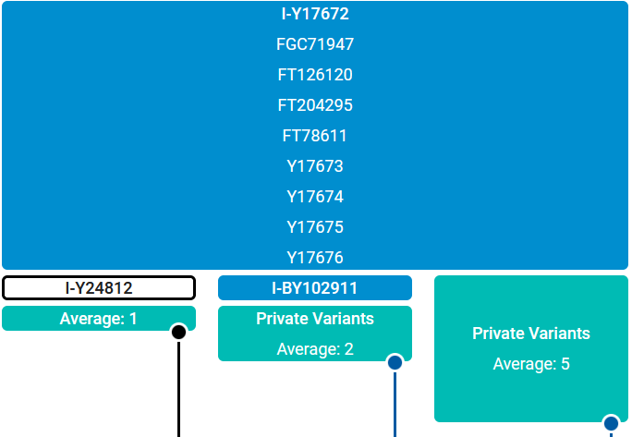

The blue and white blocks represent the haplogroups/subclades. The white block represents the subclade that the person viewing the tree is assigned to. The teal-colored blocks show the average number of private SNPs for the people assigned to the block. It should be noted that the company does not add a subclade with only one person to the tree. Rather, the people assigned to these subclades are lumped together and assigned to the parent haplogroup.
The subclade I-Y24812 on the left represents the six men of the Georgia group. The subclade I-BY102911 in the center represents the six men who descend from Major Jonathan Tipton. The teal colored block on the right represent the four men who have not been assigned to the other two subclades and are lumped together under the parent haplogroup I-Y17672.

Wish List

For the remainder of 2021, there is a sale going on at our testing company, FTDNA. If anybody is thinking about ordering a DNA test, now would be a good time to do it.
We are always looking for people that might help determine how the descendants of Thomas of Georgia connect with those of Jonathan, the immigrant. In particular, we are looking for descendants of the line Jonathan > Thomas > Jonathan (wife Eleanor Bryant). This is the line of kit 44735, who may be the link connecting the Georgia group to the main Tipton liner.
There has always been a question among Tiptons about how Noah Tipton (of Pennsylvania) connects to the mainline Tiptons. It would be nice to have one or two of these men upgrade to a BigY test.

It would also be nice to have a BigY test from someone who descends from Cesley Bryant Tipton. It is believed that he may be a descendant of Jonathan and Eleanor Bryant Tipton, but documented proof has not yet been found.
Finally, one of project members who does not carry the Tipton surname believes that he may descend from one of the sons of Benjamin Tipton (son of Colonel John) who relocated to Jackson County, Alabama.

It is recognized that a BigY test is still relatively expensive, even with the ongoing sale. The project is willing to provide some support in funding these tests. Contact Bob Tipton at rrtipton1@gmail.com for more information.

MEMORIES AND TALES
The Tipton Place, Cades Cove, Tennessee

Col. Jonathan Wade Hampton (Hamp) Tipton (b. 7 Dec 1822, d. 25 Nov 1894)

The Tipton Place on the Cades Cove Loop in the Great Smoky Mountains National Park near Townsend, Tennesee was built by Hamp Tipton in the 1870s. He never lived in this house, instead making his home in nearby Tuckaleechee Cove, though two of his daughters, known locally as Miss Lucy and Miss Lizzie, lived there while teaching teaching school in the cove.

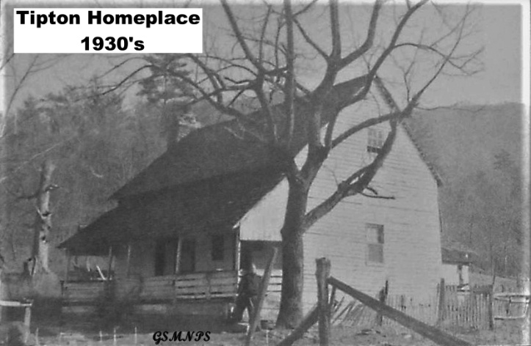
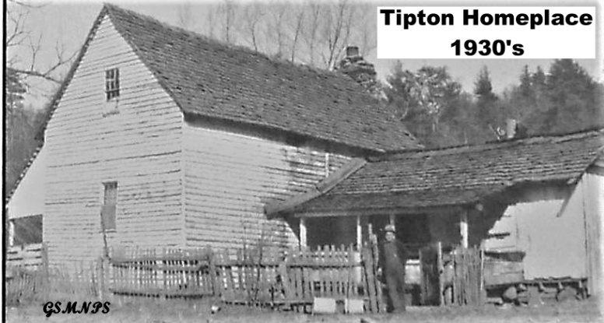

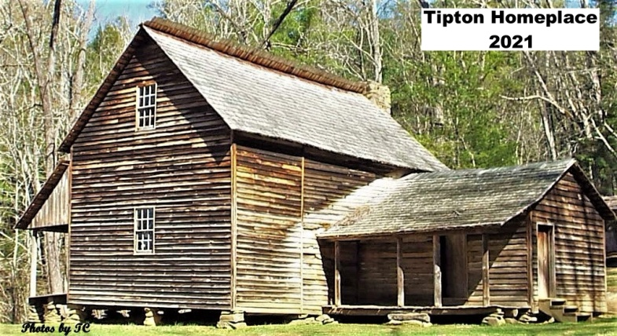
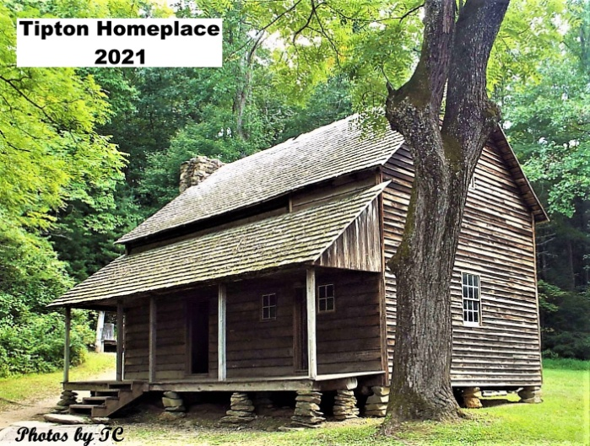

Photos submitted by Troy Collins
An 8th-generation Tipton Wedding--1913
submitted by C. Thomas Rhyne
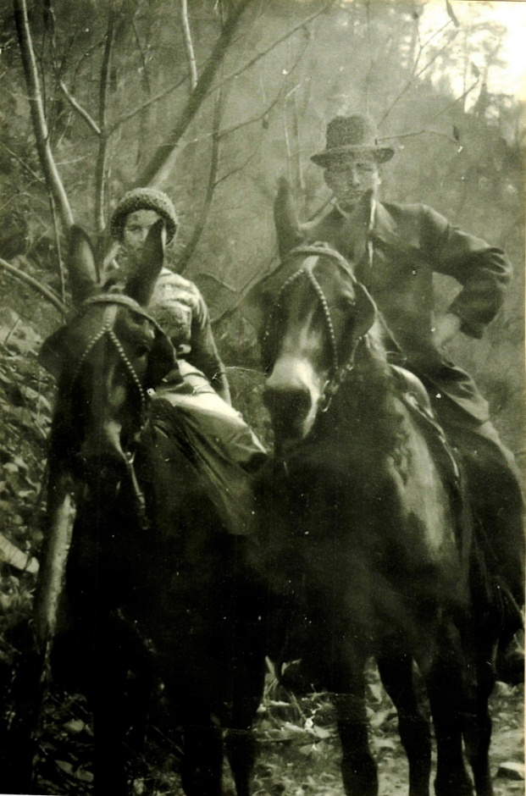

Melvina "Mellie" Lucinda Tipton
and Burl Whitehead's wedding day
August 31, 1913 in Chilhowee, TN.
Mellie was daughter of Noah and
Susannah (nee Lequire) Tipton
and a 7th GGranddaughter of
Jonathan Tipton I (1657?-1757)
through Col. John and "Fightin'
Billy" lineage.

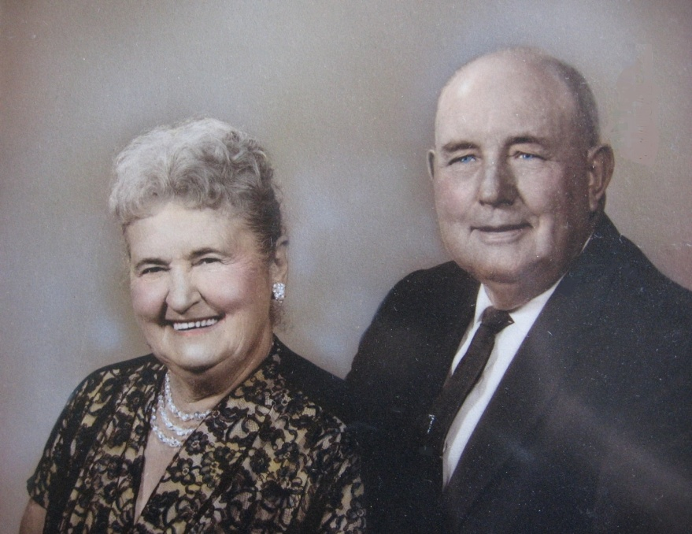

Around their 50th Wedding
Anniversary in 1963.

My grandmother Mellie Tipton was born in Cades Cove and lived there until the family moved around 1903 to Chilhowee, TN.

Melvina and Burl's daughter, Margaret Naomi (nee Whitehead) Rhyne, was my mother.
Freeman Tipton, Entrepeneur
submitted by Brad Tipton

When I first learned my Grandfather had owned the Coca Cola bottling plant in Berlin, PA, my Father related it to me as follows:

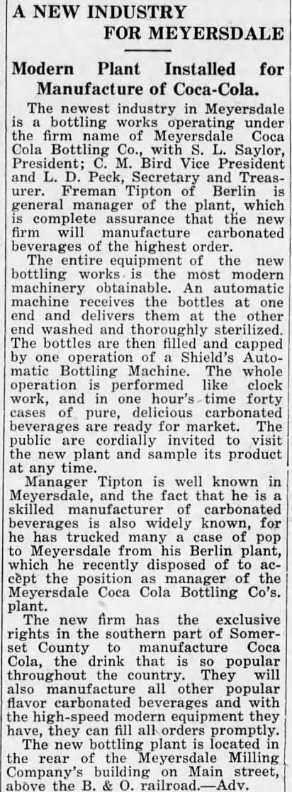
Prior to World War 1, Freeman owned the plant located about a block off the main street in Berlin, south on route 219. The last I remember seeing the building, it was abandoned and looked like a derelict old barn. There had been a more modern plant at the opposite side of Berlin that is not connected to the Family. I am not sure if this plant is still in operation.
My Father told me that when Freeman joined the Army during World War 1, he was afraid he would not return, so he signed ownership of the business over to his Mother. One of Freeman's brothers (I believe it was Leland) talked her into signing the business over to him while Freeman was in the Service. When Freeman returned after the war he was not able to get the business returned to him. I had thought that Leland sold the business and opened a jewelry store in Berlin (needs confirmation). I met Leland once, and introduced myself before he passed. He was very old and did not feel like talking for whatever reason.
My Father told me that Freeman never talked to his Mother again because of this. And, the only time he saw his Grandmother was when Freeman drove him to Grandma's house, when he was about 10 to 12 years old, pointed out the house in the row of homes and told him to introduce himself and visit.

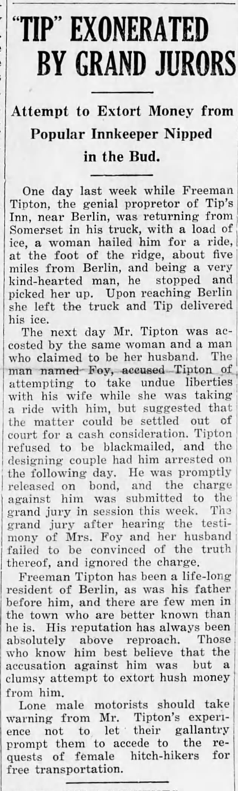
It is now obvious that the "family lore" about Freeman giving up the Berlin plant is flawed. World War 1 was from 1914 to 1918. The news article is dated May, 1926. Freeman obviously liquidated his plant to take the General Manager position. I had never heard of this and wonder how it all fits in with Freeman owning Tip's Inn, a recreational establishment, located on Rte 219 about half way between Berlin and Meyersdale, with a picnic grove, indoor roller skating rink, ice skating pond, campground, small summer cottages, small take-out restaurant and gas pumps.

Freeman was very enterprising using his Tip's Inn assets during the Great Depression. The small cottages were "portable", they could be divided in half, loaded on a flat-bed truck and hauled to be set up elsewhere. Wealthier Somerset, PA families would rent these cottages to be set up near a local stream or river, in a cool spot, to avoid the summer heat. They were hauled back in the fall. Freeman ran a "sugar camp" every spring to produce maple syrup. His syrup was superior to the products of other camps, clearer and ash-free. He boiled down the maple sap using live steam through tubes in the boiling troughs. The steam was generated by the boiler used to heat the large building that housed the roller skating rink. Other sugar camps boiled down over wood fires under the troughs, so some smoke and ash made its way into the syrup. Grandpa Freeman did tell me that there were years where they had a "bad run" of sap that would not boil down to marketable syrup. This syrup was sold to tobacco companies to flavor chewing tobacco. (Who knew?) Freeman was an "ice man". During the winter, blocks of ice would be cut from the pond and stored in straw and saw-dust insulated ice sheds. He delivered ice to households for their coolers. My deceased brother, William Tipton, used to possess one of Freeman's ice tongs. It has "vanished" since his passing. One additional "enterprise" was Freeman building a small flat-bed truck into a school bus. He was contracted to transport children to school in that very rural area.
Freeman was a "fully trained and qualified" carpenter. Where he picked that up, I do not know. I do know he worked as a carpenter for Bethlehem Steel in Johnstown, PA for many years, having retired from there. He commuted between Berlin and Johnstown during those years. Grandpa was Calvary during WW1, and experienced poison gas. In later life, while working for Bethlehem Steel he developed severe emphysema. The Company "took good care of him" covering expenses and time off for treatments. I almost forgot his bad knees from a riding accident while training in the cavalry causing a very long stay in a military hospital.

This is not everything that comes to mind. However, my Grandfather lived a full and fulfilling life, didn't he?

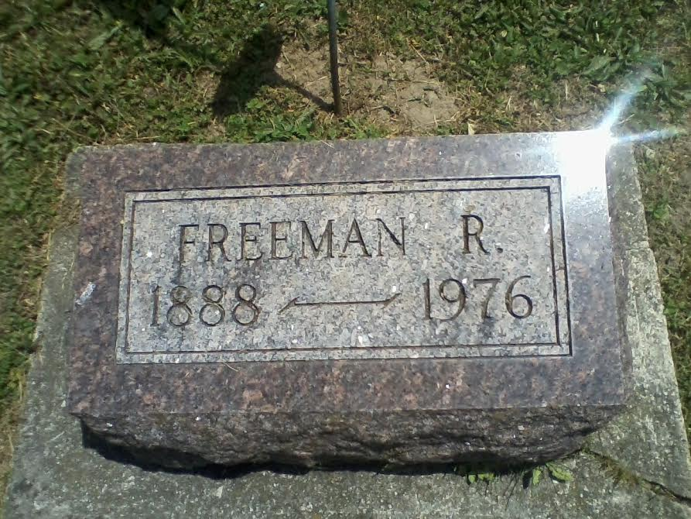
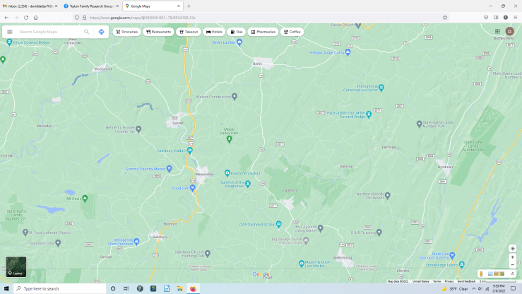

Let me introduce myself

I grew up in Missouri. All over Missouri. I still consider myself to be a
preacher’s kid. My growing up years were spent mostly in small towns—populations of 100 up to 1,000. Well, my family did live in St. Louis County, St. Charles, and North Kansas City (not Kansas City North—there’s a difference) for a few years. Always academically oriented but not terribly athletic though I did run track (badly) in high school. Sang in choir, played clarinet in band all the way from junior high through college. Majored in music for bachelor, master, and doctoral degrees. Served as a minister of music in several churches, then 26 years as a professor of church music, voice, and choral conducting and as music director for fifteen music theater productions for University of the Cumberlands in Willliamsburg, Kentucky. Now retired from teaching but still here by choice.

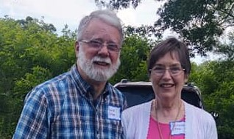
I am married to the best wife in the world (sorry guys, you can’t have her, she’s mine forever) and we have raised four children to be some of the best people I have ever known.

Though my Etter ancestors came from Switzerland and are also proud patriots I count myself as a Tipton as well since my mother, Mary Viola Tipton Etter, is a direct descendant of Jonathan Tipton I through Col. John Tipton and his son William “Fighting Billy” Tipton.

I am honored to be asked to serve as your editor for our newsletter. I hope to do you proud.

David Etter

QUERIES

Cousin Pamela McKinney <prmckinney74@gmail.com> is seeking information regarding a picture of a relative. Pamela says that her “3rd great grandmother was Rebecca Tipton McKinney of Walker Co. GA, daughter of William S. Tipton, granddaughter of Thomas J. Tipton, G/gd of Col. Jonathan.”

Writing to Kathy Hoffman, TFAA president, she said:

“Hi Kathy, I am attaching a photo that I have had for a LONG time. It says this was the home/doctor office of Dr. Tipton. I do not know which Tipton this doctor was, where he was, and am hoping with a mass emailing to the Tipton Family Association, one of the family members may know. Thank you for helping me with this.”

Also: “From my cousin Aleta in Texas, she said that the W.C. Tipton on the plaque is for William Caswell Tipton. However, I am having a difficult time finding a William...I have found a Wiley C. ??? But, the old censuses from the 1840s & 50s only give hashmarks of gender & ages in the families. No names except head of household. My Great grandmother Rebecca had a brother named Caswell C. Tipton.

I am hoping someone recognizes the big house and W.C. Tipton to solve the mystery! . . . .

Thanks for your help!

Pam”

Just below, we have reproduced the picture Pamela has provided. If you think you can help identify this Dr. Tipton you may contact her via the email address above.--DDE
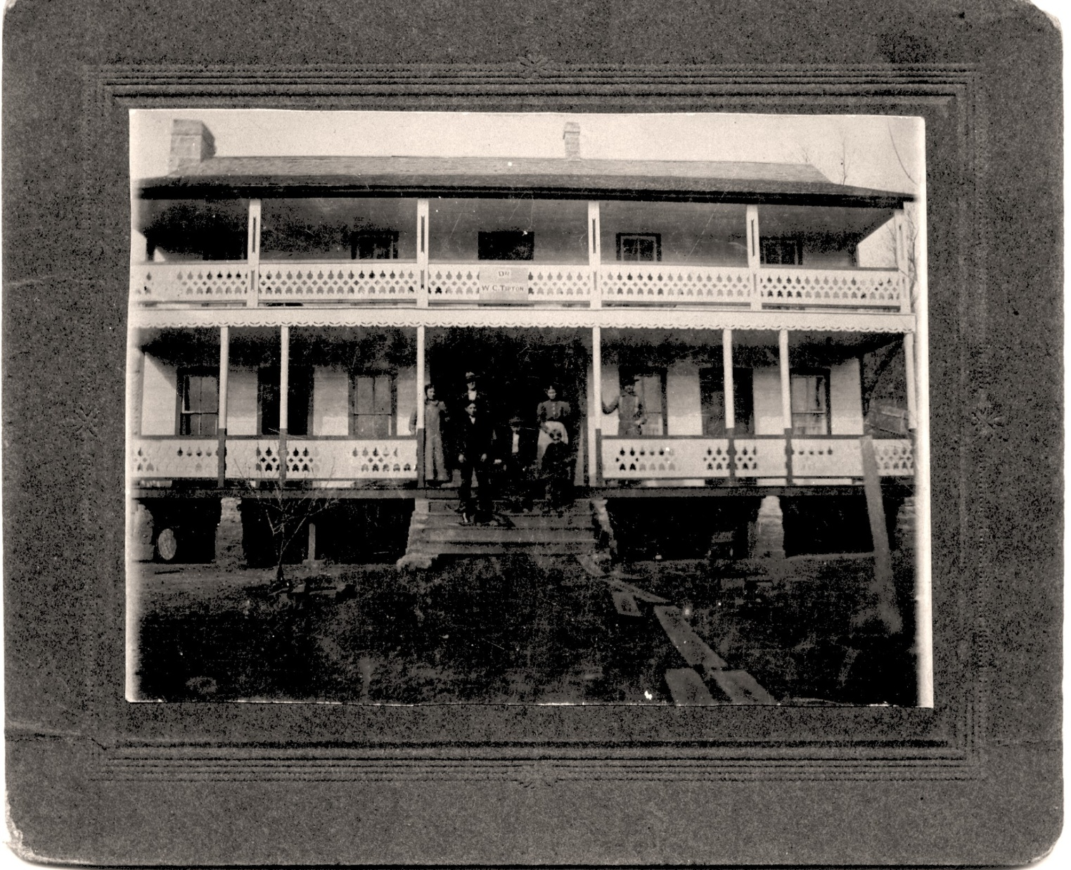

_______________________________________________________

The newsletter of the Tipton Family Association of America is a quarterly online publication that encourages submission from members to share results of their research into Tipton family lines, stories and pictures of ancestors, news of events that feature Tiptons or Tipton history, and other useful and interesting information about Tiptons.

