The Tipton Family Association of America
7132 Emily Drive, Fort Myers, FL 33908
April 2021

The Tipton Family Association of America Newsletter
President Comments
Hello Family, we hope this newsletter finds all of our family healthy and blessed.

We Welcome our new members and offer our assistance to help you all however we can. As you may already know we have an amazing family! We would like to assist you with your research and update you on projects; activities, etc. as well as sharing information.
Thank you in advance for your sharing of your research and family stories with the rest of the Tipton families.

Were our ancestors perfect?
It has been said that our Tipton ancestors had Values, hopes, aspirations, pride, spirit, love of God and Country.
While this is the absolute truth, did you know that we also had some ancestors that were stubborn, scrappy (fighting), outspoken, and not the most upstanding citizen, etc. etc.….?
Unfortunately when we start “Digging up our Family Roots” we may find something that we don’t like or something different than what we were told growing up. In my digging, I found a female Tipton that conceived her half “Tipton” brother’s child, and a Tipton cousin married a Tipton cousin and several family members that served time in prison.
I for one absolutely don’t like the negative actions of our ancestors but I accept the facts.
NO, our family was NOT perfect then nor is it perfect now, but they were and we are FAMILY!

We are moving forward with the planning of this year’s TFAA meeting/reunion.
Save the date!!! October 8th, 9th and 10th, 2021
Location: Woodstock VA area
Our agenda is packed this year so you will not be bored.
If you have a musical talent please let me know so that we can add you to the evenings TFAA Tipton Talent show.

Tipton Team Work!!!!
Kathy Hoffmann

TFAA Committee
President -Kathy Hoffmann
Co-President-Kathy Brewster Price
Treasurer- Vacant
Secretary- Cathy Tipton Lowe
Communications Director- Charles Tipton (aka Junior)
TFAA Tipton Research Director- Charlotte West Dade
Tipton Family DNA project Administrators- Bob Tipton and Bonnie Grant
Chairperson of Wm “Fighting” Billy Grave Site - Ashley Draper

Provided by: Larry Sparks
WWI Veteran Mike Tipton
Larry Sparks and Ruth Caughron Davis along with the National Park Service started a “wayside board” project in Cades Cove in 2014 in order to show visitors that come to the Cove what the community was like before it became a National Park. These “wayside” boards are informative! Did you know that our own WWI Soldier Mike Tipton is on one of the wayside boards in Cades Cove? Mike Tipton’s information is located on a board on the back side of the Cove at the Witt Shields overlook. It honors our Cades Cove military service.
Mike Tipton was the son of George and Margaret Tuckaleechee Burchfield Tipton.
Thank you Cousin Larry Sparks for all you do in Cades Cove!

Provided by: Charles and Jo Tipton
This article is from the Daily Journal and Tribune Knoxille TN June 15, 1913
Fatal Pistol Duel
Newspaper article of Charles E. (jr) Tipton’s grandfather Joseph Green Tipton, who died June 14, 1913.

Officer and Man He Sought to Arrest Shoot Each Other.
Knoxville, Tenn., June 14.-Deputy Sheriff John Sliger and Joe Tipton, whom he was trying to arrest, killed each other last night on the public highway near Rugby Tenn. Tipton had been drinking and was firing his pistol promiscuously when Sliger demanded his surrender. Tipton turned his weapon on the officer and the two men began shooting simultaneously. When the smoke had cleared away both were dead within a short distance of each other.

Looking for information

Our cousin Laura Lefler is working on a project and is seeking our help. She is focusing on all the Tipton’s that were from Carter County, TN, and Mitchell and Yancey Counties in North Carolina that served in the Civil War. Do you happen to have any stories or documents that were passed down in your Tipton family about them serving in the Civil War? She would love to include your family in the mix.
Please email her at lauralefler54@gmail.com

Submitting Articles or Information

Family Stories and Tales
TFAA does NOT guarantee stories are fact or fiction.
If you have submitted an article or family stories and tales and have not seen in published yet, I may have saved it for another edition or unfortunately may have forgotten to publish it, please feel free to gently remind me through email. Peachyrose56@gmail.com
Stories and research that are submitted to me is pretty much published as it is received.
Because we have family and friends that are visually impaired but love to read our newsletters and research information and the electronic readers are unable to interpret or read photos or documents that are scanned, I would ask that when you submit your stories please put them in a word document. Thank you

Provided by: Nancy Walker
Nancy provided copies of Knoxville Sentinel 1908 newspaper articles that she clipped about the Tipton's. They are pretty interesting and you can read them on the website under “Tipton News” drop down.
Titles are:
*Tipton Family From Scotland
*John Tipton was a fearless Citizen
*Jonathan Tipton lll sat in Legislature
*“Billy” Tipton’s Fighting Record
*More Facts as to Tipton Family
*Tipton Family Record Closed

Thank you Nancy

Provided by: Kathryn Dreier
Kathryn shared an informative story about Snag boat Captain David Tipton that she found at the Minnesota Historical Society but due to copyright material we cannot include the photos and story.
You can go to the website and look for “OUT with the FLEET on the Upper Mississippi, 1898-1917.
http://collections.mnhs.org/MNHistoryMagazine/articles/37/v37i07p283-297.pdf

Provided by: Kathy Hoffmann
The US DAVID TIPTON was built in Jeffersonville, Indiana in 1900.
The ship was 0wned by the U.S. Engineering Department.
Her skipper, Captain David Tipton, died at the wheel of the MACKENZIE on Lake Pepin, near Reads Landing, Minnesota September 22, 1904 and the boat was renamed in his honor. The U.S. Engineers operated her on the upper Mississippi River until 1920

Please check out the below listed website for more information.
https://steamboats.com/museum/davet-photossnagboats1.html
Steamboats.com

Provided by: Brad Tipton

My Wife (Marlene) and I (Brad Tipton) were standing behind the cameraman during the Tom Hanks interview. Unfortunately we did not get to meet him. We were at the Major Dick Winters memorial service because Mrs. Winters hand delivered an invitation, with reserved seating beside the "family box" in the Hershey Theatre. This occurred because my Wife, as a very excellent C N A, was the primary caregiver to Mr. Winters in a nursing home during the last several months of his life. Both the Major and his Wife loved my Wife's attention to, loving care of and personality towards them. My wife had to hold this assignment a secret from me, which she did, until after Dick's passing. She cites this experience as the HIGHLIGHT of her 50 year career as a CNA.
We were also in a position to observe Wild Bill Guarnere entering the theatre. Old and frail, with only one leg, and aided by uniformed men. He was seated front and center to the stage.
Sometime later, we attended Mrs. Winter's funeral and interment beside her beloved Husband, in the cemetery outside of Ephrata, PA. True to their post war lives, it was a modest occasion and, their grave sites are very modest. We were able to talk to Dick Hocksworth, who had become a good friend to the Major through many interviews. He was very pleasant and informative. He gave me some time to show him a monument to a WWI Ephrata soldier who had fallen and, according to the monument, "buried somewhere in France". Mr. Hocksworth appreciated this.
Everything considered, this was an experience that Marlene and I will NEVER FORGET.

Robert Clayton Tipton
Robert Clayton Tipton, 81, of Berlin, died April 21, 2017, at Meadow View Nursing Center, Berlin. Born Sept. 13, 1935, in Geiger, PA, he is the son of Pauline Margaret (Tipton) Whipkey-Mitchell. Preceded in death by his mother; brothers, Charles Whipkey Jr., Richard Whipkey; and sister Rose Brant. Survived by his sisters: Shirley Barndt of Friedens, Barbara Coffman of Saxton, and Peggy Kaufman of Somerset; also numerous nieces and nephews.

William “Fighting Billy” Grave Update

If you recall, a few months ago our Cousin Marie Tipton went to Fighting Billy's grave and advised that it was in need of some repair and cleaning.
A few days ago with some directional help from Marie, my husband and I set out to locate the family graveyard, and assess what tools/equipment will be needed for a major cleaning-up project.
As we know, the family graveyard is on private property in Blount County (TN), and the current property owner passed a couple of years ago. His property is in a "Trust". I mailed the Trust a letter from TFAA advising them of our desire to visit the gravesites, clear property, and repair markers.
We tracked through overgrown, downed trees, heavily natural debris and up a pretty steep hill to a ridge about a 1/2 to 1 mile from the house located next to site. At the site we found that most of the markers (field stones) were covered with limbs, leaves, small saplings and vines. There were a few small trees (about 1 inch in diameter) that I believe should be removed.
We did what we could with kicking the leaves off the graves and moving the downed trees that were on them. Nothing else was moved! Once I removed the leaf debris from Fighting Billy's headstone, there was a penny that had been placed there. No way of knowing how long it had been there, but I left it as it was found.
Marie told me about a TVA tower located close to the site. What a great find! TVA has an easement under the powerline that is overgrown. This path seems to be a bit closer and not as steep.
I called TVA to find out if we could not only mow that path/easement from the main highway to the gravesite and use it as a foot and vehicle path to the gravesite. I spoke with two managers who told me they have the "Tipton Grave" on their map, and they spray and mow that area every three years. Presently, it is not up for maintenance until sometime next year (2022).
We are still working out some of the details and will update you as more information becomes available. If you are interested in helping with this project once we get details finalized, please email me.
Please enjoy several photos taken from our adventure. We will select a few of them, and add to the TFAA website at William’s link.
Provided by: Kristy Tipton

Great Grandfather to Kristy
David Sulden Tipton born October 28, 1851 Tipton Hill, Mitchell County NC
Died Aug 31, 1936 Tipton Hill, Mitchell County NC
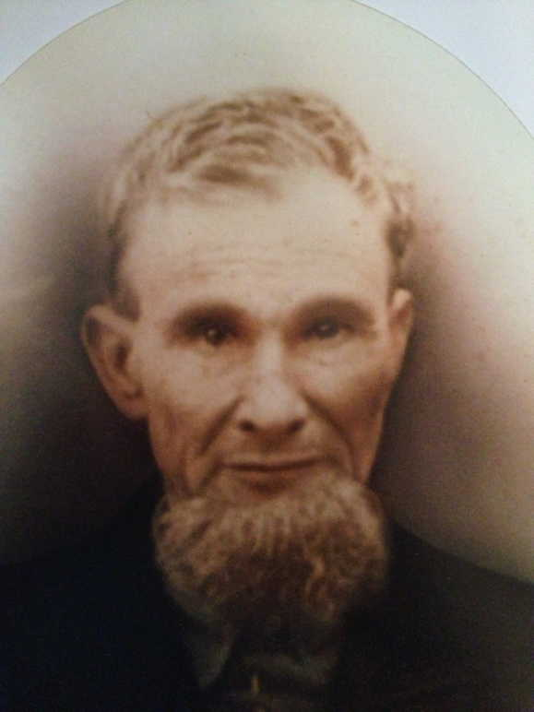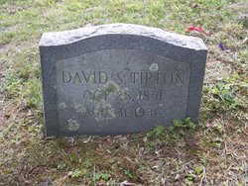
Photos of David S Tipton and His Headstone

James Gudger Tipton
Born Jan 1, 1882 Tipton Hill Mitchell County NC
Died Aug 24, 1883 Tipton Hill Mitchell County NC
Father David Sulden Tipton
Headstone
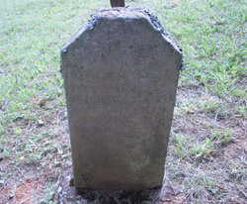

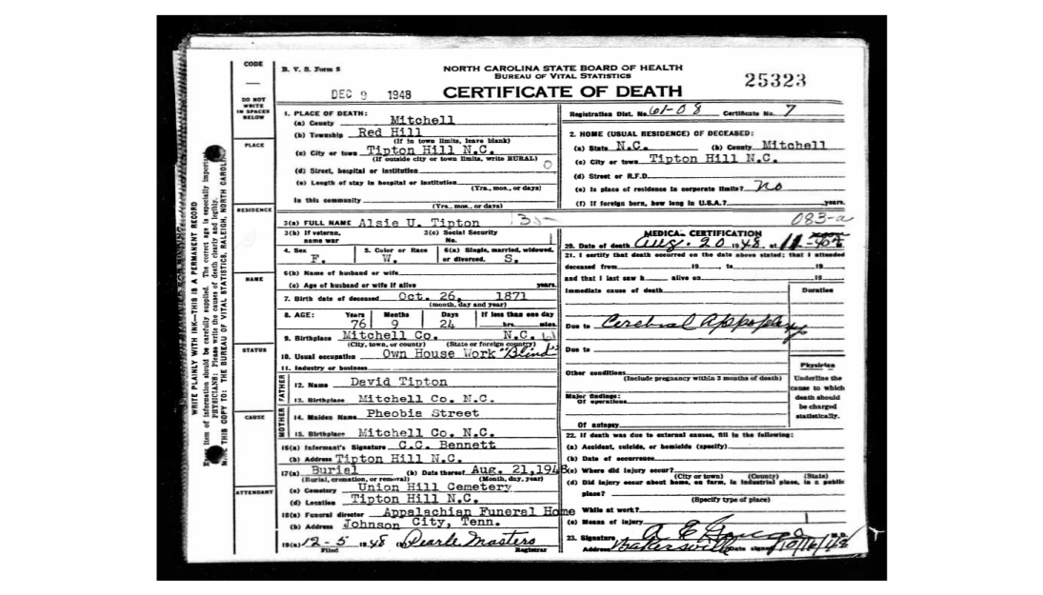

North Carolina State Board of Health Bureau of Vital Statistics
Certificate of Death (above)
Place of Death: Mitchell County, Red Hill, Tipton Hill NC
Name: Alsie U. Tipton
Female, White, Single
Date of Death: August 20, 1948
Date of Birth: October 26, 1871
Age at death: 76 years 9 months 24 days
Birth Place: Mitchell Co. NC
Usual Occupation: Own House Work “Blind”
Father: David Tipton
Mother Maiden Name: Pheobia Street
Burial: Tipton Hill NC, Union Hill Cemetery

Homer Donald Tipton Born Dec 14, 1915
DIED January 17, 1979
Buried in Gainesville GA
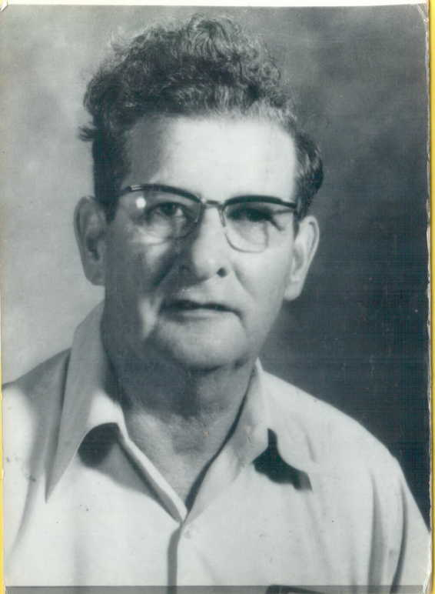

Donald Ray Tipton Born November 17, 1952
Son of Homer Donald Tipton Mary Frances Tipton 9-16-1948
Daughter of Homer Donald Tipton
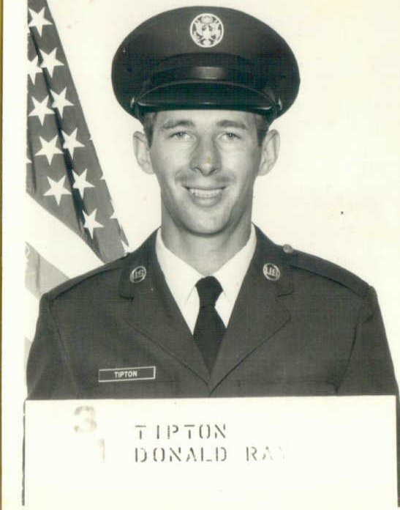

Homer’s Children
Larry, Eva Mae, Frankie, Ray, Tiny
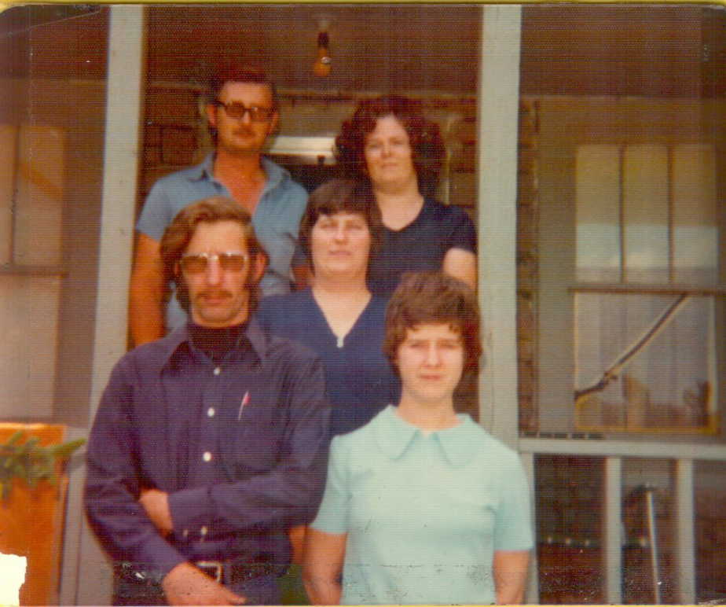

Larry Dale Tipton Born July 29, 1947
Died August 7, 1976
Buried in Craig- Tipton Family Cemetery in Blowing Rock NC on the Blue Ridge Parkway
The cemetery is not marked with a sign

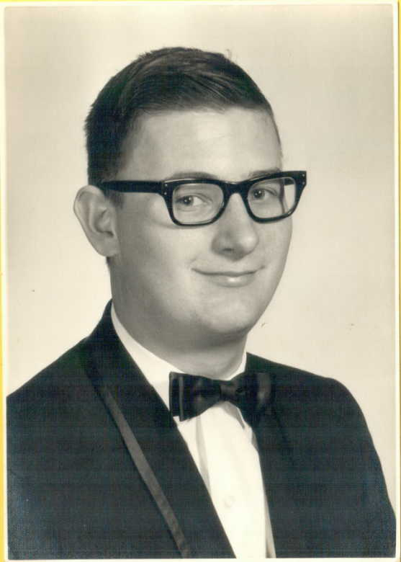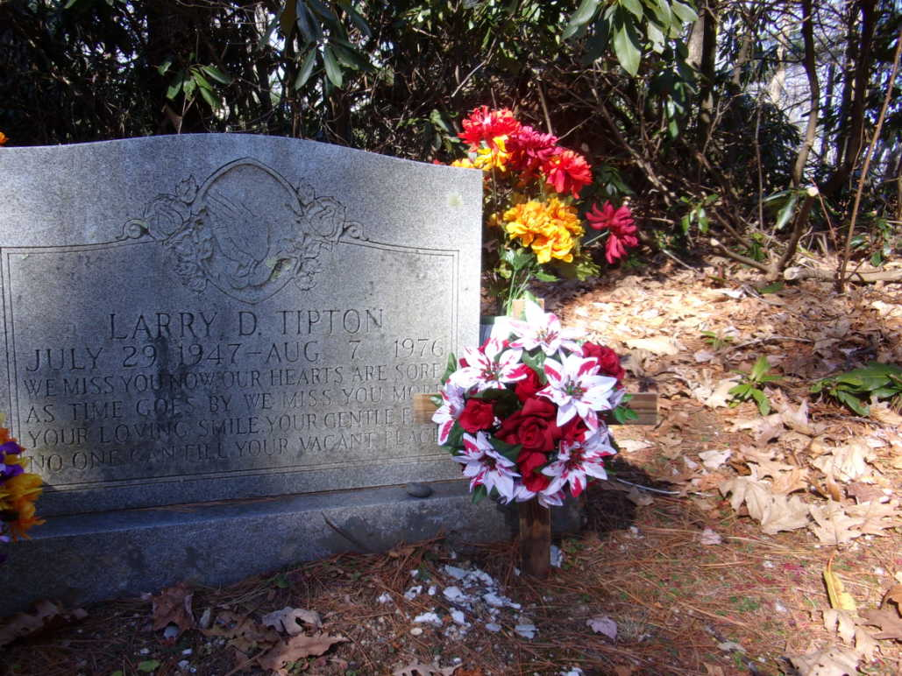

Eva Mae Hunter is the sister of Larry and daughter of Homer Tipton
Born October 5, 1945
Died April 27, 2018
Buried in Craig- Tipton Family Cemetery in Blowing Rock NC on the Blue Ridge Parkway

Provided by: Adrian Roberts
Adrian has shared these couple of pictures he took of documents in the UK National Archives in Kew.
Note from Adrian to TFAA:
Typton v Hynton dates from 1538-1544 and is a record of a court case brought by Floryce, son and heir of Thomas Typton, against Thomas Hynton, concerning land in Minsterley, Shropshire (where my husband was born).
(Floryce Typton complains that Hynton has wrongfully entered and kept land that Thomas bequeathed to him 4 years earlier). The National Archives record number is C 1/1076/82.
Tipton v Tipton (National Archives Record no C3/464/89) is a later case, from 1648, brought by Anne Typton (widow of Roger) against “Florence” Typton (I think this is Florus Florentinus Tipton), again concerning an inheritance of land in that part of Shropshire.
Adrian has a clearer copy of this, but it’s an enormous file as it’s a composite of a number of photos and is happy to send it if anyone is interested. He advises that he hasn’t had time to decipher the whole thing.
The Shropshire Tiptons were very litigious, and often fell afoul of the law, so there is a lot of legal material waiting to be discovered in the archives.
adrianpaulroberts@icloud.com

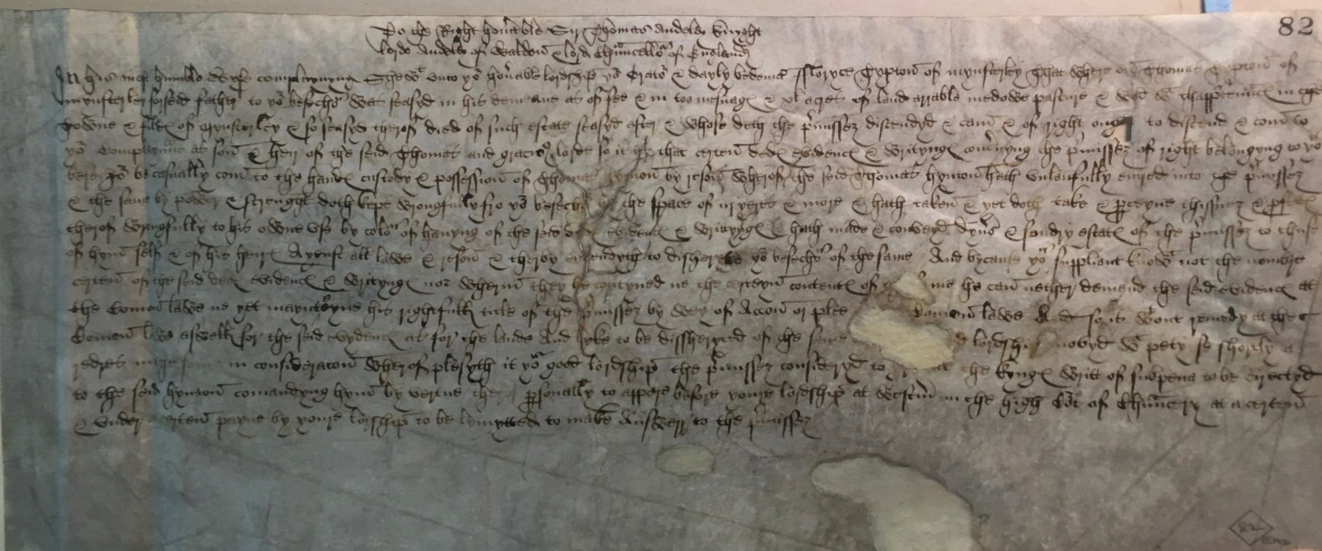

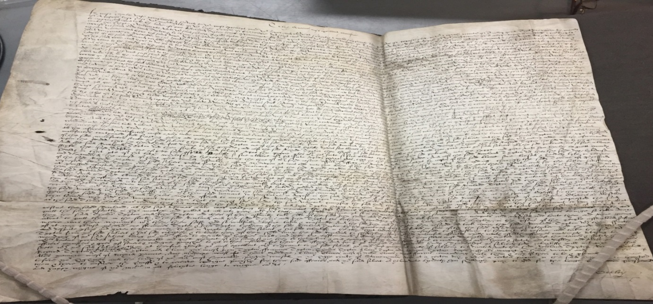
We hope that one day these documents can be transcribed.

Provided by: Robin Cooper

I am transcribing the content so our visually impaired family and friends are able to read it.

Tipton Cemetery
Located off of Maryville Pike in South Knox County. The cemetery which has now been destroyed was once located near the interssection of Maryville Pike and Tipton Station Road on property occupied at present by the Arrowhead Subdivision. During the early 1900’s several of the existing stones (and remains) were removed to Woodlawn Cemetery (w-441). What remained became known as a slave cemetery and by the time of work project administion in the late 1930’s the cemetery was referred to in the community as a “Old Slave Graveyard”.The following information was obtained from the cemetery checklist done at that time; Name:Cagle Farm, old slave graveyard, Location: Maryville Pike - 7 miles from courthouse and 3 miles from Mt. Olive. Foundering Date: Older than the State of Tennessee_ Years and Years ago, Size: there used to be 15 or 20 markers, but now there may be 1 or 2. Comments: This is an old slave burial ground and hasn’t been used in years and years. Mr. Cagle is the present owner, before him Harrison Pickens owned it and prior to Pickens it was known as the Tipton place. It is said this burial ground is now being used as a pig sty. The cemetery was formerly the burial place of at least two sons of William “Fighting Billy” Tipton, who was a Revolutionary War Soldier and is buried in Blount County nearby. At present nothing remains to indicate the site was ever used for burial purposes. Copied and researched in May 1999.
The following information was obtained from stones at Woodlawn Cemetery, or from the Woodlawn Cemetery records.
Jane (Roddy) wife of Abraham Butler Tipton married April 29 1806, December 16th 1789- December 26th 1852 aged 61 years and & 10 days
Mary Jane daughter of Wm. C. & Rebecca Jane Tipton, wife of Daniel C. Hommell married Febrauary 21 1855. December 2, 1835 – November 1862
Wm. C. son of Abraham Butler & Jane Tipton married Rebecca Jane (Doyle) on July 18, 1833. March 16 1812-June 25, 1877 aged 65 Years, 8 months & 9 days (stone broken in 4 four pieces)
Abrahan Butler son of William & Phoebe Tipton March 3, 1783 – November 15 1831 Private Captain William Walker’s and Colonel John Williams “Company War of 1812 (see will)

The following graves were recorded as having been moved with no stones:
(in one place there is a note that fieldstones with some inscriptions were found but not relocate to Woodlawn. I believe that is the source of these names)
Ruben son of William & Phoebe Tipton born circa 1782 Died circa 1839 Major Chiles’ Regiment Mounterd Gunmen Soldier War of 1812 (see will)
Mary (Reed) 1st wife of Ruben Tipton married December 3 1805. Born circa 1785 Died circa 1820
Rebecca Jane (Doyle)wife of Wm C Tipton married July 18 1883 Born 1815 Died between 1870-1880
Jabez Thurman Born Virginia c1794 Died between 1880-1891
Ailey (childless) married 1st Ruben Tipton on October 1 1820, wife if Jabez Thurman married June 4 1846. Born circa 1803 Died between 1870-1880

Kathy’s notes: I have included the paper “Below”, but unfortunately
part of the will was left out. You may wish to research the will of “January Session 1832 Will of Abraham Tipton.

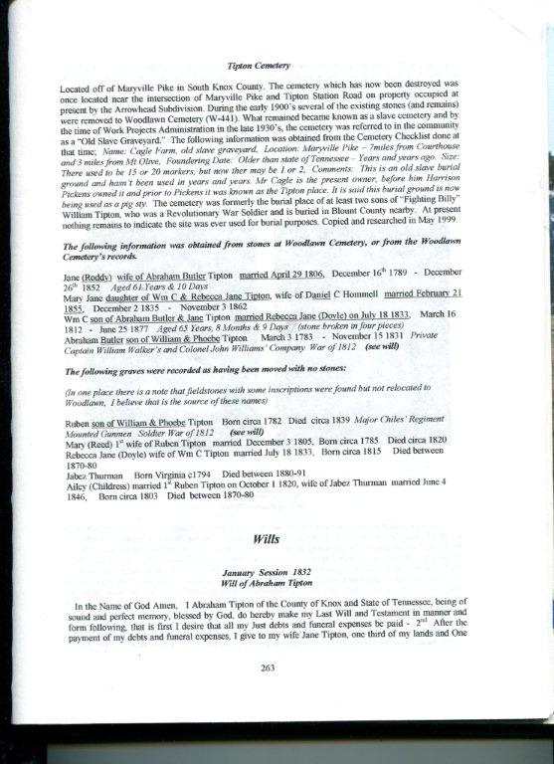

Provided by: Chris Scruggs
This picture is Lizzie and she was the sister of Julia Tipton Vassey 1879-1912 NC.

Julia’s family was:

Husband: Riley Milton Vassey

Children:
Haskel Thurman Vassey
Timmons W. Vassey
Calvin Boyd Vassey
James Manly Vassey
Ruby Vassey Bridges

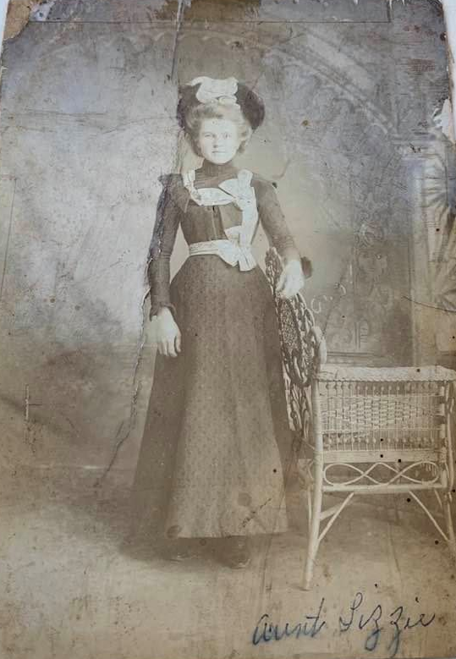

Chris Scruggs is looking for more information on the parents of Julia Tipton Vassey. If you have any information please contact Chris via text ONLY. (hearing impaired) 704.974.9648 text only

Provided by Lexie Santangelo
Billy Gene Tipton Obit
June 27, 1926 - February 9, 2021
Billy Gene Tipton, age 94 years, of Raritan Township, NJ, died peacefully on Tuesday, February 9, 2021 at home, surrounded by his loving family and under the caring watch of Hunterdon Hospice.
Born on June 27, 1926 and raised in Paris, Missouri, Billy was a devoted husband, father, grandfather and great grandfather who lived a life filled with many varied and rich experiences and opportunities.
As a young man Billy explored all of the lower 48 states, getting to know his country sometimes hitch-hiking and at other times working the rails. While visiting New York City he decided to join the Merchant Marines and set sail to experience the world. After many years sailing he met his future wife, planted roots in New Jersey and raised a large family.
After retiring from the Merchant Marines Billy worked for the Ford Motor Co. while attending Rutgers University at night eventually becoming a corporate facility engineer. He spent most of his career working for Lily Tulip/Owens Illinois in Holmdel, NJ and the State of New Jersey, Treasury Dept.
Billy’s personal creed was set goals, work hard and always give more than you receive. His greatest love, without compare, has been his wife of 69 years, Madeline.
He was preceded in death by his parents, Stribling and Lucille Murphy Tipton, and by his brother, John.
Surviving are his cherished wife, Madeline Cairns Tipton; his children and their spouses, Elizabeth and Nick Mariolis, William and Christine Tipon, Michele and Mark Walters, Pamela and Mike Mills, Melissa and Jim Dempsey, and Stephanie and Patrick Kane; fifteen grandchildren; four great grandchildren, his brothers-in-law and sisters-in-law, Michele and Henry Bowden and Arnold and Betty Cairns; several extended family members; and many dear friends.

Billy’s granddaughter, Lexie said that before settling down in NJ to raise her mom (his daughter) and her 5 siblings, her Pa spent a lot of time at sea traveling the world, as it talks about in his obituary. He also did really love his wife, fishing, reading the news, and watching our family grow!

Provided by: Brad Tipton - 1986 OBIT:

Robert F. TIPTON, 1986, native of Berlin, Somerset County, PA
Robert F. Tipton, 59, 330 East Roseville Road, Lancaster, Pa , died March
30, 1986, at home. Born in Berlin, son of the late Freeman R. and Lena
(Deeter) Tipton. Survived by wife, Mary P. "Polly" (Pugh) Tipton; three
children: R. Bradley, at home; William R., Lititz, Pa.; and Elizabeth T.,
wife of Stephen Kirchner, Lancaster; three grandchildren and four adopted
grandchildren. Brother of Jack C., Falls Church, Va. Vice President of
Applied Research & Development at Science Press, Ephrata, Pa.; three-term
director of the National Composition Assoc. in Washington, D.C., and a
member of numerous International Printing Trade Organizations. In 1980, he
was honored with the Key Employee Award of the National Assoc. of Printers
& Lithographers, for devising Science Press's automated systems for
computerized typesetting and composition. He also played a major role in
setting up the company's museum. Member of the Grace United Church of
Christ in Lancaster. A graduate of Berlin High and the University of
Pittsburgh. He also attended Carnegie Mellon University and Franklin &
Marshall College, where he taught evening classes in Graphic Arts. A former
employee of the Somerset Daily American, the Johnstown Tribune-Democrat and
the Meyersdale Republican. He was a staff sergeant in the U.S. Army in
Germany and France during World War II. A member of the American Legion
Post 445 in Berlin.

OBIT:
John W. TIPTON, 1931, of interest in Somerset County, PA

JOHN TIPTON

Berlin, Sept. 8 - John W. Tipton, aged 76 years, passed away suddenly at the
home of his son, C. W. Tipton, on Friday evening. Early in the evening Mr.
Tipton had taken an automobile ride, and at about 9:30 expired. He had been
unwell for some time, but was feeling better of late. His death was a shock to
his many friends. He is survived by the following children: James W. Tipton,
Altoona; Mrs. H. F. Heffley, Washington, D.C.; Mrs. Binnie McQuade, Allegheny
Township; Mrs. C. R. Bowman, Somerset; Clarence W. Tipton, Freeman R. Tipton,
and Mrs. B. Z. Stuck, of Berlin. He is also survived by the following brothers
and sisters: Noah Tipton, Hyndman; James Tipton, Allegheny Township; Mrs.
Elizabeth Brown, West End; Mrs. Nellie Lafferty, Somerset.

Meyersdale Republican, September 10, 1931

Provided by: Larry Sparks

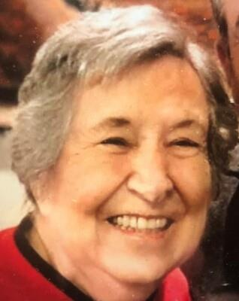
Lenore Andes Obit 2021

Lenore Sparks Andes was the granddaughter of Margaret Tennessee Tipton and John Burchfield and great granddaughter of George Tipton.
Knoxville - Lenore Sparks Andes (89) of Knoxville, Tenn. went to be with our Lord on Saturday, April 17, 2021.
She was born in Cades Cove on July 24, 1931 and was one of 12 children born to Asa and Amy Sparks, and she was one of the last remaining families to reside in the cove before it became a National Park.
She graduated from the University of TN and taught home economics before marrying Rex Andes of Sevierville. She joined Rex in the restaurant business where they successfully operated The Steakhouse in Sevierville and then moved to Knoxville and operated the Hollywood Restaurant and Andes Catering for over 30 years. Lenore was a devoted wife and mother to 6 children while successfully running the family business.
Upon retirement she enjoyed gardening, square dancing, spending time with her family and traveling. She traveled to Italy, Australia, Fiji, Mexico and all over the United States. She was a devout Christian and member of Wallace Memorial Baptist Church.
She is preceded in death by parents Asa and Amy Sparks, husband Rex Andes, brothers Leon and Luke Sparks, and sister Lennis (George) Walvoort, grandson Jacy Jackson and brother in law Benny McCarter.
She is survived by her sisters Lucille (Bob) Britton, LaVerne McCarter, Lois Kaye (Charles) Russell, Linda (Mike) Denton, brothers Leland (Edna) Sparks, Leslie (Annie Sue) Sparks, Larry (Katie) Sparks, Lamon (Gail) Sparks, children Samantha (Charlie) Owens, Amy Andes, Carrie (Harvey) Halcott, Lisa Andes, Keith Andes, James (Felicia) Andes, and Carmen (Dennis) Lindsay, 13 grandchildren, 11 great grandchildren, many nieces and nephews, and her dear friend Gene Frye.
Lenore always had a smile on her face, and will be missed by all who knew her.

OBIT 2021

Franklin Ray Tipton

FEBRUARY 5, 1942 – FEBRUARY 12, 2021

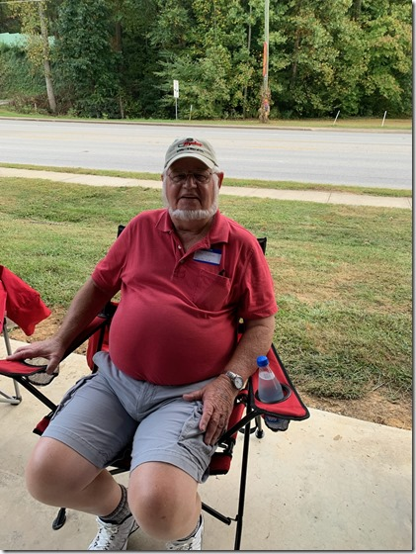

Mr. Franklin Ray Tipton, age 79 of Jonesboro, GA, entered into eternal rest on Friday, February 12, 2021.
Franklin was born to the late Hoyt and Rachel Tipton on February 5, 1942 in Walland, Tennessee. As a high school graduate, he enlisted in the military and became a member of the 82nd Airborne Infantry Division of the United States Army. Franklin was a member of the American Legion Post 258 in Jonesboro, Georgia and also served as a past master of Rex Masonic Lodge 251. In his spare time, he enjoyed spending time at the Veterans of Foreign Wars Post 6330 as well. Franklin never met a stranger and always had a story or a joke to tell. He was loved by many and will be missed by all who knew him.
In addition to his parents, Hoyt and Rachel Tipton, Franklin was preceded in death by his wife, Mrs. Carolyn Paulette Tipton and one son, Timothy Ray Tipton. He leaves to cherish his memory one daughter, Rachelle Cowart of Jonesboro, GA; a special friend, Teresa Jones of Ellenwood, GA; four siblings, Len Tipton (Brenda), Edie Brown (Dick), Lori Crook (Richard), and Brenda Horton; six grandchildren, Tabatha Denson, Ashley Bell (David), Kenny Cowart, Amanda Crawley (James), Andrew Tipton, and Amber Wright (Robert); nine great-grandchildren, many cousins, extended relatives, and friends.

Obituaries hold a lot of family information and your lineage may be connected!

